2cnd Period Turnitin.com Class ID & Password

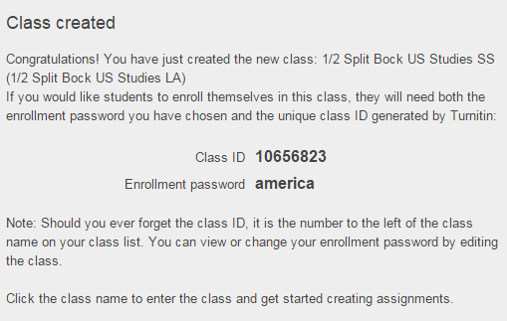

5/6 Period Turnitin.com Class ID & Password

