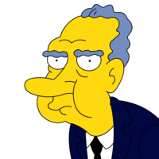
Name:
Period:

The United States v. Richard Millhouse Nixon

Document 1: US v. Nixon Case Brief

- What were the 3 reasons Nixon gave for refusing to turn over the White House tapes?
- What do these reasons tell you about Nixon’s views on Presidential power?
- What did Chief Justice Burger say about the origins of executive privilege? How does this origin justify his decision about Nixon releasing the tapes?
- Explain Burger’s statement, “A President and those who assist him must be free to explore alternatives in a way many would be unwilling to express except privately.” How did the court interpret executive privilege?
- How did this court case expand the power of the presidency?

Document 2: “The Smoking Gun Transcript”
Transcript of White House Tapes, June 23, 1972 – conversation between President Nixon and Chief of Staff H.R. Haldeman. (Note: Pat Gray is the Acting Director of the FBI, and Mark Felt is the Associate Director of the FBI. Helms is the Director of the CIA and Walters is the Deputy Director of the CIA)
1. Haldeman tells Nixon, “the FBI is not under control.” Why does the FBI need to be controlled?
2. What is Nixon’s plan for dealing with the investigation of the Watergate Break-In?

3. What does this transcript tell you about the relationship between the FBI and the CIA?

4. What does this transcript tell you about Nixon’s views on Presidential power?

5. Why is this transcript called the “Smoking Gun”?

