How to Choose and Use Quotations – Practice with TKAM

Choose an essay prompt to respond to for this activity (end of packet). Use the following to help you decide how to choose and use textual evidence to best support your thesis. Once you have selected passages that support your ideas, be sure that you properly integrate and format your citations. Practice what you’ve learned on the last page.

USE THE LEAST AMOUNT OF A QUOTED PASSAGE YOU CAN TO SUPPORT YOUR POINT.

Don’t quote less relevant parts of a passage; use only what supports your point directly, even cutting the quote down to only the most significant words from a sentence. This allows you the space in your paper to fully explain the significance of the quote. Your voice should be the dominant one in your paper.

In The Adventures of Tom Sawyer, Aunt Polly reveals her conflicted feelings about how to raise Tom when she says, “Spare the rod and spile the child, as the Good Book says. I'm a laying up sin and suffering for us both, I know. He's full of the Old Scratch, but laws-a-me! he's my own dead sister's boy, poor thing, and I ain't got the heart to lash him, somehow. Every time I let him off, my conscience does hurt me so, and every time I hit him my old heart most breaks. Well-a-well, man that is born of woman is of few days and full of trouble, as the Scripture says, and I reckon it's so. He'll play hookey this evening” (Twain 74). | Which is best?  Put an X through the quote heavy sample. | In The Adventures of Tom Sawyer, Aunt Polly reveals her conflicted feelings about how to raise Tom when she says, “Every time I let him off, my conscience does hurt me so, and every time I hit him my old heart most breaks” (Twain 74). Conventions of 19th century American society dictated that one must beat or spank children to teach them lessons, but throughout his novel Twain reveals Aunt Polly’s anxiety about physically abusing Tom.

EXPLAIN THE QUOTATION.

Don’t assume the reason you are using a piece of textual evidence is obvious to your reader. For every line of a source you quote, expect to write two or three lines of your own analysis and explanation after it.

In The Adventures of Tom Sawyer, Aunt Polly reveals her conflicted feelings about how to raise Tom when she says, “Every time I let him off, my conscience does hurt me so, and every time I hit him my old heart most breaks” (Twain 74). Conventions of 19th century American society dictated that one must beat or spank children to teach them lessons, but throughout his novel Twain reveals Aunt Polly’s anxiety about physically abusing Tom. Aunt Polly’s “conscience” is in conflict with her “heart,” like many Americans who felt forced to choose between social stability and social justice during this tumultuous time in history.

YOU TRY w a TKAM QUOTE:

DON’T CHANGE THE MEANING OF THE QUOTATION.

Take the time to ensure that you understand the passages you choose to support your thesis, both in their context in the larger work, as well as how the author may have intended the passage to be interpreted. See how excerpting just a part of Aunt Polly’s monologue misrepresents Aunt Polly’s complex and conflicted feelings:

Aunt Polly believes that physically abusing children is acceptable: “Spare the rod and spile the child, as the Good Book says.”

Clearly the writer has misinterpreted the text here. Read the passages before and after a quote you want to use to clarify the author’s intended meaning.

Integrating Quotations into Your Paper

A student must consider what type of essay she is being asked to write and choose appropriate reporting verbs to introduce another author’s words in her essay. ALL QUOTES MUST BE INTRODUCED = NO DROPPED QUOTES!!!

CHOOSING REPORTING VERBS: Objective or subjective analysis?

Determine whether your assignment is asking you to be informative (objective) or persuasive (subjective) and independently, or with a tutor, decide which reporting verbs might be most appropriate to use when quoting another author:
- Circle three verbs that you could use to report an author’s words, neutrally. (objective)

- Underline three verbs that offer an opinion about an author’s words. (subjective)

acknowledges*  addresses  adds  admits  advises  agrees  analyzes  announces  answers  argues  asks  asserts  believes | cautions  charges  claims  clarifies  compares  complains  concedes  concludes  concurs  confirms  considers  contends  contests | continues  criticizes  critiques  declares  demonstrates  describes  determines  disagrees  discusses  disputes  elaborates  emphasizes  examines | explains  expresses  finds  grants  identifies  illustrates  implies  indicates  insists  interprets  introduces  maintains  mentions | notes  objects  observes  offers  opposes  points out  posits  postulates  presents  proposes  raises  refutes  rejects | remarks  replies  reports  responds  reveals  says  shows  specifies  states  suggests  thinks  translates  writes
* MLA convention requires that you write in present tense, but students should always confirm expectations
with their instructors.

USING VERBS: Integrating Quotations

Sentence format | Objective | Subjective
Introductory phrase with a colon: “…” (Matis 104). | • Influenced by extensive research, scientists agree that the theory holds true so far: “…” (Mungawa et.al 7). | • Garcia criticizes Lelands’s logic: “…” (para. 12).
Using an introductory phrase and comma, “…” (Jones 23). | • McGain asserts, “…” (222).  • “…,” Barber observes (56). | • Always the gentlewoman, Barret only implies her opponent’s idiocy when she cautions, “…” (118).
Using phrases to “complete the sentence” (Cruz 17). | • Elia claims no impartiality and agrees he is “not the right person to make this decision.” | • Brown obstinately believes that “all errors of this type are unacceptable.”

YOU TRY using verb set-up w TKAM QUOTE: objective OR subjective practice

Properly Formatting Quotations in MLA Format
Once you have selected quotes that support your ideas, proper citation of their sources is important in order to avoid plagiarism or misrepresentation of information. The following examples are excerpted from the MLA Handbook for Writers of Research Papers (6th ed.), section 3.7.

INTEGRATING QUOTATIONS

Quotes need to be integrated into your own writing with a setup/tag. Here are three ways to incorporate quotes:

• Shelley held a bold view: “Poets are the unacknowledged legislators of the World” (794).

• Shelley thought poets “the unacknowledged legislators of the World” (794).

• “Poets,” according to Shelley, “are the unacknowledged legislators of the World” (794).

YOU TRY one w TKAM QUOTE:

BLOCK QUOTATIONS
Use “block quotes” if the quote you are using runs more than four lines in your paper. Block quotes are introduced with a colon, each line is indented two tabs’ length, and the quote does not require quotation marks. The parenthetical reference is included at the end, outside of the final punctuation:
At the conclusion of Lord of the Flies, Ralph and the other boys realize the horror of their actions:
The tears began to flow and sobs shook him. He gave himself up to the now for the first time on the island; great, shuddering spasms of grief that seemed to wrench his whole body. His voice rose under the black smoke before the burning wreckage of the island; and infected by that emotion, the other little boys began to shake and sob too. (186)

SPECIAL PUNCTUATION
If the quote includes question or exclamation marks used by the author, include that special punctuation, but maintain the capitalization, lower case letters and periods of your own writing:

• “How can I describe my emotions at this catastrophe. . . ?” wonders the doctor in Mary Shelley’s Frankenstein (42).

• Dorothea Brooke responds to her sister, “What a wonderful little almanac you are, Celia!” (7).

If you, as the writer, choose to use special punctuation to comment on a passage you are quoting, the special punctuation will fall outside of the quotation marks.

• He attacked “taxation without representation” (32).

• Did he attack “taxation without representation”?

• What dramatic events followed his attack on “taxation without representation” (32)!
EDITING QUOTATIONS
If you remove words from a quote that you cite,* replace those words with an ellipsis: three periods with a space between each ( . . . ). If the ellipsis falls at the end of a quotation, omit the first space.
• In surveying responses to plagues in the Middle Ages, Barbara W. Tuchman writes, “Medical thinking … stressed air as the communicator of disease, ignoring sanitation or visible carriers” (101-02).

• In surveying responses to plagues in the Middle Ages, Barbara W. Tuchman writes, “Medical thinking, trapped in the theory of astral influences, stressed air as the communicator of disease. . . ” (101-02).
* If you edit an author’s words, be sure that you honestly represent the author’s ideas, and maintain correct grammar.

YOU TRY w TKAM QUOTE:

INTEGRATING QUOTATIONS WITH TRANSITIONAL WORDS & PHRASES

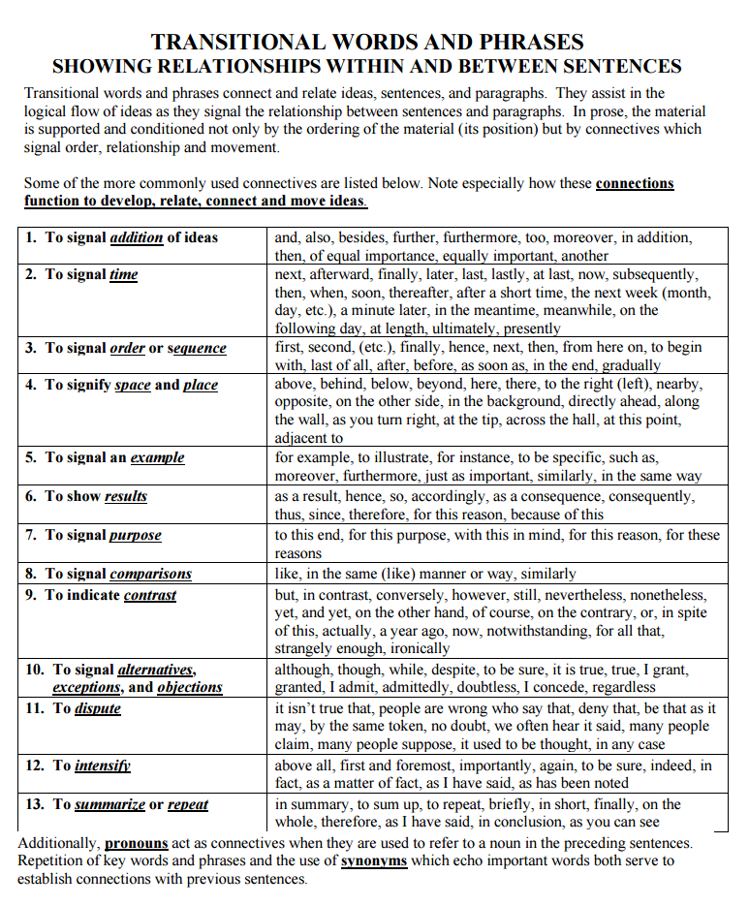

YOUR TURN – Choose an essay prompt to respond to.

YOUR TASK: Practice integrating your TKAM quotes by using the aforementioned guidelines to write a thesis statement and a body paragraph that responds to one of the essay prompts, below.
TKAM ESSAY PROMPTS
PROMPTS 1-3: Respond to one of the following essential questions using at least two characters from To Kill a Mockingbird:
- Can one person change society?
- How are prejudice and bias created, and how do we overcome them?
- How is innocence lost, and what replaces it?
PROMPT 4: Atticus tells his children to “consider things from [another person’s] point of view… [to] climb into his skin and walk around in it” (30). How do Jem and Scout learn from this advice throughout part one of To Kill a Mockingbird? What do they learn about others?

Write an essay in which you consider how Jem and/or Scout’s perspective changes about another character in TKAM. Consider how Jem and/or Scout’s view changes (before/after) about Atticus, Mrs. Dubose, Boo Radley, Walter Cunningham, or any other character of your choosing from part one.

- Parenting. What kind of parent is Atticus Finch? Describe the values he seeks to instill in his children through the lessons he teaches Jem and Scout directly and those he teaches by his example.
- Big Ideas. What are the big ideas or themes of To Kill a Mockingbird? Consider what the novel teaches about justice, prejudice, courage, attitudes towards those who are different from us, race relations, etc.
- Mockingbird Metaphor. Why is this novel entitled To Kill a Mockingbird and which character(s) best fits the mockingbird metaphor and why?
- Character and Moral Development. Choose either Jem or Scout. In what ways does Jem or Scout change and grow throughout the novel? For example, at the beginning of the novel, Jem and Scout are afraid of the Radley place, but by the end, Scout fearlessly walks Boo up to his front porch. What change has taken place in Scout that allows her to walk with Boo? Additionally, how do Jem’s or Scout’s morals develop throughout the novel? What stage(s) of Kohlberg’s moral development best describes Jem’s or Scout’s current level?
- Jim Crow and Race in the South. Not only does race divide the town of Maycomb, it also dictates the ways in which characters conduct themselves in relationships. For example, Calpurnia speaks “n-talk” at her church but speaks “white folk” talk when she is with the Finch’s. What are the hidden rules of conduct the people of Maycomb follow because of race? How does race structure relationships in terms of power, language, and social status? Lastly, is Harper Lee challenging the status quo about race relations through To Kill a Mockingbird (is her novel political?) or is she merely describing life as it is in Maycomb?
- Ethical Dilemmas. What are the major ethical dilemmas of To Kill a Mockingbird? How do different characters resolve these dilemmas? What ethical systems inform their resolutions? Please discuss why these ethical dilemmas are indeed dilemmas (i.e. complex situations that have multiple solutions yielding varying results) and the strengths and weaknesses of characters’ resolutions and outcomes.
- Other – get teacher approval
YOUR TURN – Practice Choosing and Using Quotations with TKAM

Use your TKAM book and your Character Description (handout) self-selected quotes to develop a thesis response and a single body paragraph that responds to your selected essay prompt. You must:

- Use complete sentences
- Explain/lead the quotation (TLQ [transition, lead, and quote])
- Use 2 different types of quote integration.
- Properly MLA format your quotes
- Use and circle reporting verbs. 2x
- Use and box transition words . 2x or more

Prompt# selected:
My essay thesis (with TAG) that directly answers the prompt:
Body Thesis Statement (sub-thesis that supports my essay thesis):
Integrated text evidence 1:
Analysis 1a:
Analysis 1b:
Integrated text evidence 2:
Analysis 2a:
Analysis 2b:
Closing Sentence:

