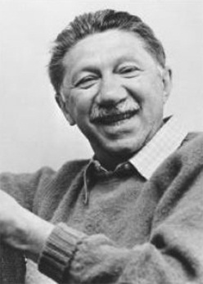
"The story of the human race is the story of men and women selling themselves short."
– Abraham Maslow (1908-1970)

Maslow’s Hierarchy of Needs
By Kendra Cherry
What motivates behavior? According to humanist psychologist Abraham Maslow, our actions are motivated in order achieve certain needs. Maslow first introduced his concept of a hierarchy of needs in his 1943 paper "A Theory of Human Motivation" and his subsequent book Motivation and Personality. This hierarchy suggests that people are motivated to fulfill basic needs before moving on to other, more advanced needs.
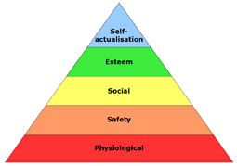
While some of the existing schools of thought at the time (such as psychoanalysis and behaviorism) tended to focus on problematic behaviors, Maslow was much more interested in learning more about what makes people happy and the things that they do to achieve that aim. As a humanist, Maslow believed that people have an inborn desire to be self-actualized, to be all they can be. In order to achieve these ultimate goals, however, a number of more basic needs must be met first such as the need for food, safety, love, and self-esteem.

From Basic to More Complex Needs
This hierarchy is most often displayed as a pyramid. The lowest levels of the pyramid are made up of the most basic needs, while the more complex needs are located at the top of the pyramid. Needs at the bottom of the pyramid are basic physical requirements including the need for food, water, sleep, and warmth. Once these lower-level needs have been met, people can move on to the next level of needs, which are for safety and security.
As people progress up the pyramid, needs become increasingly psychological and social. Soon, the need for love, friendship, and intimacy become important. Further up the pyramid, the need for personal esteem and feelings of accomplishment take priority. Maslow emphasized the importance of self-actualization, which is a process of growing and developing as a person in order to achieve individual potential.

Types of Needs
Maslow believed that these needs are similar to instincts and play a major role in motivating behavior. Physiological, security, social, and esteem needs are deficiency needs, meaning that these needs arise due to deprivation. Satisfying these lower-level needs is important in order to avoid unpleasant feelings or consequences.
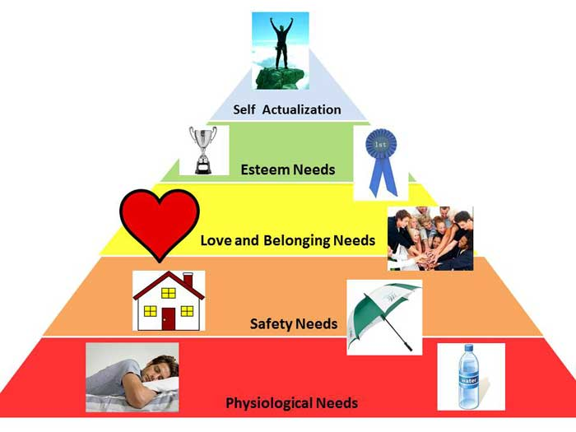
Maslow termed the highest-level of the pyramid as growth needs (or being needs). Growth needs do not stem from a lack of something, but rather from a desire to grow as a person.
Five Levels of the Hierarchy of Needs
There are five different levels in Maslow’s hierarchy of needs:
Physiological Needs
These include the most basic needs that are vital to survival, such as the need for water, air, food, and sleep. Maslow believed that these needs are the most basic and instinctive needs in the hierarchy because all needs become secondary until these physiological needs are met.

Security Needs
These include needs for safety and security. Security needs are important for survival, but they are not as demanding as the physiological needs. Examples of security needs include a desire for steady employment, health care, safe neighborhoods, and shelter from the environment.

Social Needs
These include needs for belonging, love, and affection. Maslow described these needs as less basic than physiological and security needs. Relationships such as friendships, romantic attachments, and families help fulfill this need for companionship and acceptance, as does involvement in social, community, or religious groups.

Esteem Needs
After the first three needs have been satisfied, esteem needs becomes increasingly important. These include the need for things that reflect on self-esteem, personal worth, social recognition, and accomplishment.

Self-actualizing Needs
This is the highest level of Maslow’s hierarchy of needs. Self-actualizing people are self-aware, concerned with personal growth, less concerned with the opinions of others, and interested fulfilling their potential.
Instructions: Read the attached article
Write which need goes in which section of the pyramid
Write down examples of each need in each the
Corresponding portion of the pyramid.

