This assignment is worth 35 process points.

25 Points for labeling all of the items on the list (.5 each)

5 Points for neatness & spelling

5 Points for color

LATIN AMERICA

**NAME: _________________________________________**

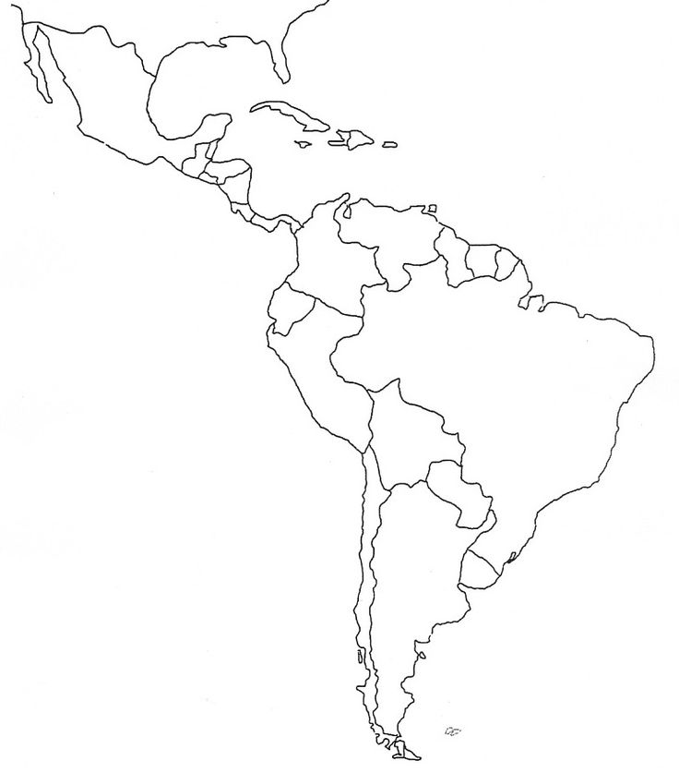

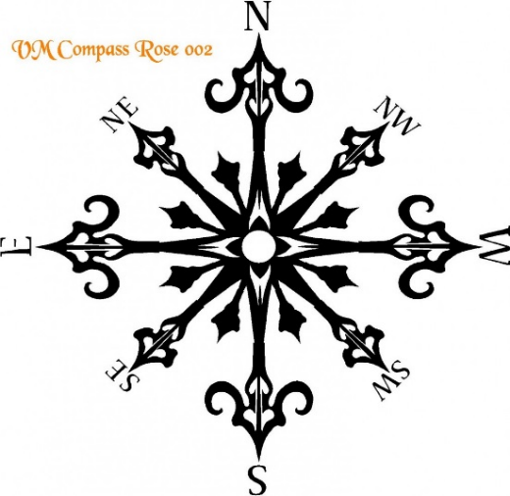

**General**

* Colored neatly
* Labels easy to read
* Items spelled correctly

**Water Features**

* Caribbean Sea
* Gulf of Mexico
* Atlantic Ocean
* Pacific Ocean
* Rio de la Plata
* Amazon River
* Parana River
* Lake Titicaca

**Countries:**

* Mexico
* Guatemala
* Belize
* Honduras
* El Salvador
* Costa Rica
* Nicaragua
* Panama
* Cuba
* French Guiana
* Suriname
* Guyana
* Venezuela
* Colombia
* Ecuador
* Peru
* Bolivia
* Brazil
* Chile
* Paraguay
* Argentina
* Uruguay
* Haiti
* Dominican Rep.

**Physical Features**

* Atacama Desert
* Amazon River
* Andes Mountains
* Patagonia
* Tierra del Fuego
* Cape Horn
* Greater Antilles
* Yucatan Peninsula
* Pampas Lowlands

**Cities / Ancient Kingdoms:**

* Cusco
* Lima
* Mexico City
* Buenos Aires
* Quito
* Bogotá
* Manchu Picchu (Inca)
* Cajamarca (Inca)
* Chichen-Itza (Mayan)