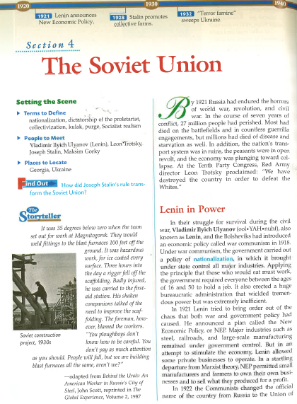

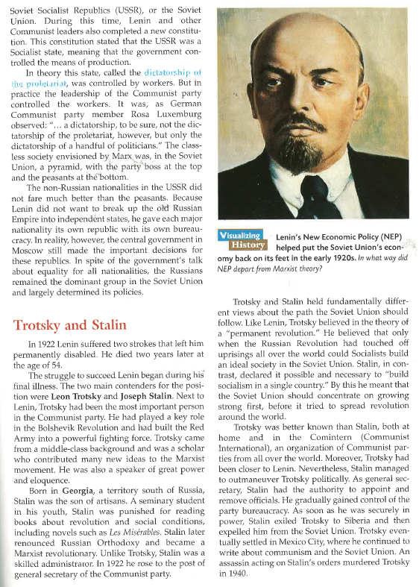
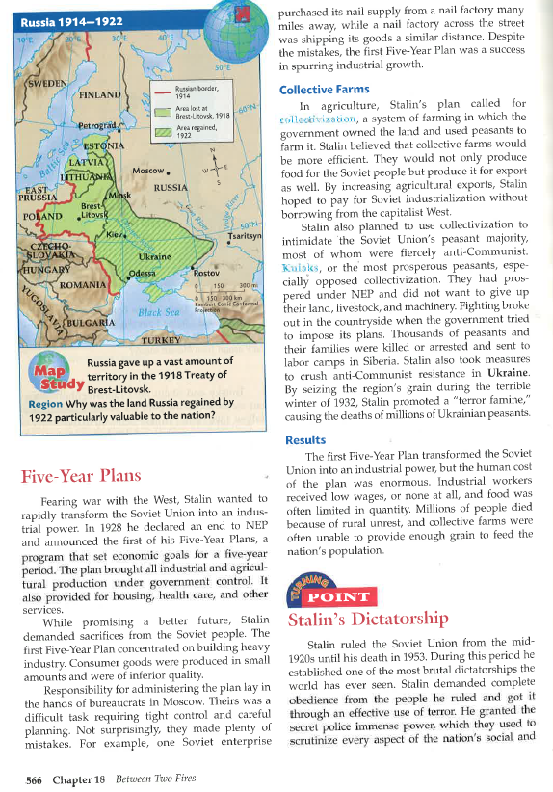

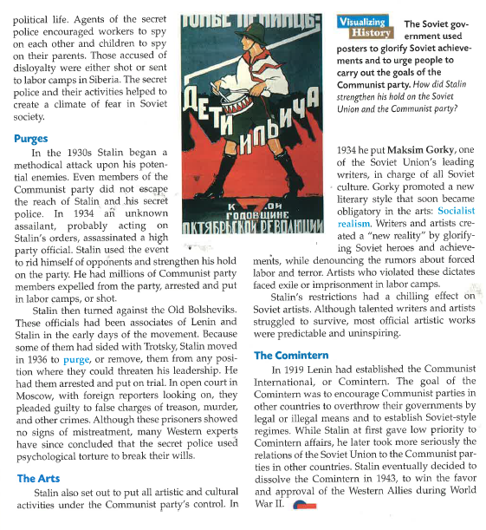

Name:___________________________________________ Date:________________________________________
Reading Questions – Answer in complete sentences & complete thoughts. The expectation is that you are detailed in your responses to these questions.
- What was life like in Russia while Lenin was in power? Explain.

- Who was Trotsky, what were his views on how to rule? Explain.

- Why didn’t Trotsky take power over Stalin? Explain.

- What were the 5 Year Plans, what were Stalin’s goals for the 5 Year Plans? Explain.

- What is Collectivization? Explain.

- Who were the Kulaks, how did Stalin treat them? Explain.

- What style of rule/power did Stalin use? Explain.

- What were the Purges, was Stalin paranoid? Explain.

- What were Stalin’s goals with the Arts? Explain.

- Was Stalin truly a Communist? Explain you answer in detail.

- Based on this article how would you define Stalin’s version of Communism (Stalinism)?

