Priscilla Presley: Revisiting Elvis' Final Days, Drug Abuse in New Documentary Was 'Difficult'

KRISTEN O'BRIEN

March 15, 2018 06:25 PM
It’s been over 40 years since the death of one of America’s most beloved musical icons, and yet with Elvis Presley: The Searcher, audiences may still discover new things about The King.
The documentary, which premieres on HBO April 14, takes viewers on a creative journey from Presley’s childhood through the final 1976 recording sessions held in the famous Jungle Room of his Memphis estate, Graceland.
The rock legend’s former wife and longtime love, Priscilla Presley, executive produced the film, and on Wednesday she gathered a host of music minds and luminaries for an insightful panel held during SXSW festival in Austin, Texas. Alongside director Thom Zimny, Sony Music’s John Jackson, and legendary country songwriter/producer David Porter, the group discussed Presley’s Memphis roots and early Beale St. influences, as well as his authenticity as an artist and superhuman ability to connect with fans.
The film doesn’t shy away from Presley’s fatal descent into prescription drugs and ill health, but according to director Zimny — who often consulted with Priscilla on the content of the film — “it’s not a clear black and white situation. When I was looking at certain tracks [from] the very end of his life…I still have this feeling that there was a man who was connecting to the music and that this story has been told one way. Sitting and listening to that music and also talking at length with Priscilla, I realized that we were going to be able to touch on some of the tragic moments, not dwell in the details of it.”
More importantly, the director said, is the “feeling that was coming through the music … that he was still connected, he still was trying. And there is sadness there but there is also still this beauty.”
Priscilla admitted it was hard to revisit her former husband’s “final chapter” and relive the painful memories through the film: “It was difficult for all of us, we certainly didn’t see it coming. But we certainly saw the journey he was taking.”
ADVERTISING
inRead invented by Teads
Priscilla Presley at SXSW.
Jack Plunkett/Invision/AP/Shutterstock
She mentioned there were highs and lows that came with being married to Presley, and that people still ask why those close to him failed to stop his prescription drug dependence — which may have contributed to his heart attack at age 42.
“People go, well why didn’t anyone do anything?” said Priscilla. “Well, that’s not true. People there in the inner group did, but you did not tell Elvis Presley what to do. You did not. I mean, you’d be out of there faster than a scratched cat. They would try and no way. He knew what he was doing.”
Priscilla said she even tried to hide pills from him when they were together, under pillows and under the telephone. “But oh my God, he knew,” she said. Presley took sleeping pills because he had insomnia and a fear of going to sleep, a phobia Priscilla says went back to his childhood.
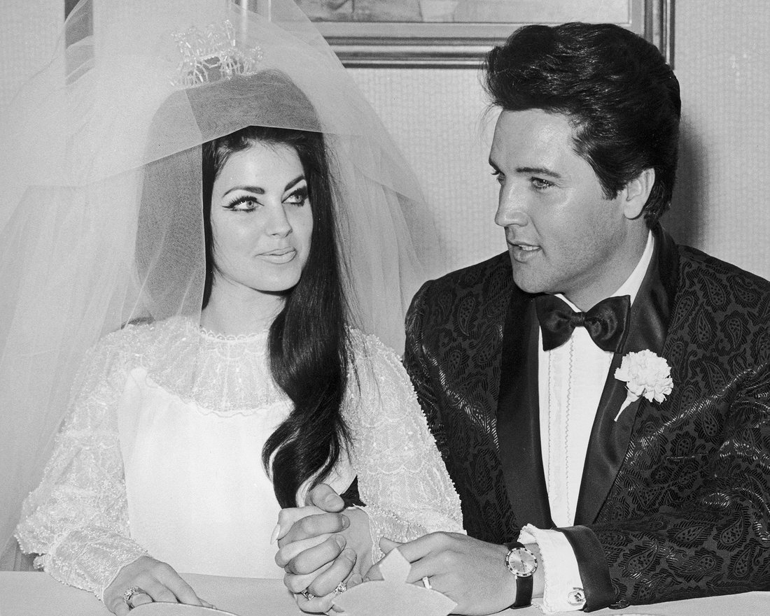
Elvis and Priscilla Presley at their 1967 wedding
Hulton Archive/Getty
She went on to explain that Presley started taking pills during his two-year stint in the U.S. Army while stationed in Germany.
“That was the thing — they gave them to the soldiers over there to keep them awake,” she said. “He was on guard at that time. He had maneuvers that he had to do late at night, so the pills were given to the guys and that’s how he started. And if you take a sleeping pill, you have to do something to get yourself awake. … He was in unchartered territory, he truly was, and he did this and tried to do this alone.”

