Elvis’ addiction was the perfect prescription for an early death
Health Aug 16, 2018 5:34 PM EDT
Today’s tears belong to musical monarch Aretha Franklin, the Queen of Soul, who died Thursday at age 76 of pancreatic cancer.
But on this day 41 years ago, millions of music lovers wept to the news that Elvis Presley, the King of Rock ‘n’ Roll, was dead. He was only 42 years old and a bloated, fading version of the once-beautiful man whose rhythmic hip-swaying earned him the nickname “Elvis the Pelvis.” His girlfriend, Ginger Alden, found him unconscious, lying face down in the master suite bathroom on the second floor of his Memphis mansion, Graceland.
Elvis was taken by ambulance to the Baptist Memorial Hospital, where the medical staff was known to be more discrete than the far-closer Methodist South Hospital. Once there, doctors struggled to revive him without success and Presley was pronounced dead at 3:30 pm.
His medicine chest was filled with amber-colored, white-topped vials of medications, in doses no responsible doctor would have prescribed.
Later that afternoon, a team of pathologists, Drs. Eric Muirhead, Jerry Francisco, and Noel Florredo, conducted a two-hour post-mortem examination. At 8:00 pm, Dr. Francisco, who only witnessed the autopsy, acted without the consent or agreement of the other two pathologists in announcing to the press that “preliminary autopsy findings” indicated that Elvis’s death was due to a “cardiac arrhythmia” and that drugs were not involved.
This statement was subsequently demonstrated not to be the case. Indeed, the other two pathologists later admitted that Francisco was covering up the real cause of death at the request of Elvis’s mortified family who were concerned about the singer’s reputation. After all, how would it look if the rock star who President Richard Nixon awarded a special badge from the Bureau of Narcotics and Dangerous Drugs had died of a drug overdose?
When the toxicology report came back several weeks later, however, Elvis’ blood was found to contain very high levels of the opiates Dilaudid, Percodan, Demerol, and codeine — as well as Quaaludes. The other two pathologists Muirhead and Florredo eventually revealed they also had found evidence of severe and chronic constipation, diabetes, and glaucoma during their examination.
Elvis actually died a death that is quite common, albeit an embarrassing one. Elvis was sitting on the toilet, straining very hard to have a bowel movement — a maneuver that put a great amount of pressure on his heart and aorta. Thus, he likely died of a massive heart attack and keeled over onto the floor. But Elvis was not suffering from garden-variety constipation at the time of his death. Indeed, his medicine chest was filled with amber-colored, white-topped vials of medications, in doses no responsible doctor would have prescribed.
Presley was a long-time abuser of opiates, which not only kill pain but also cause savage constipation. He abused antihistamines, tranquilizers such as Valium, barbiturates, Quaaludes, sleeping pills, hormones — and laxatives, for the constipation.
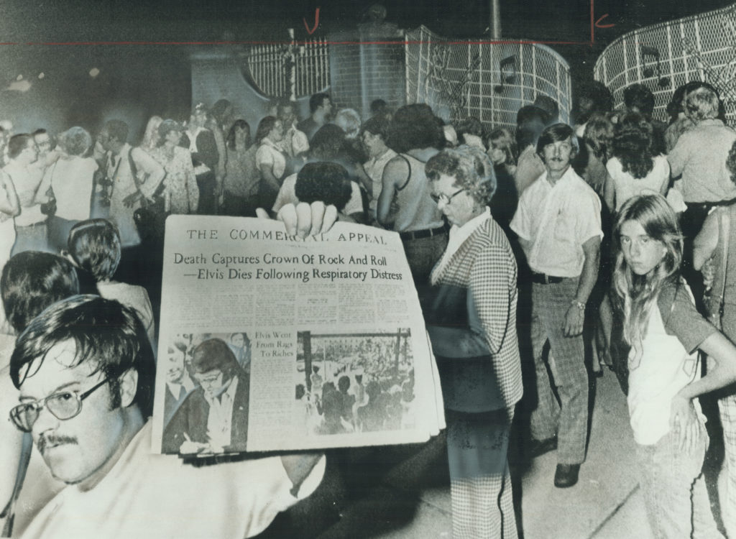
Mourners stayed all night outside Graceland, where 42-year-old Elvis Presley died. A man holds newspaper announcing his death. Photo by Fred Ross/Toronto Star via Getty Images
Elvis’ personal physician, George Nichopoulos, or “Dr. Nick,” was at Elvis’ beck and call for nearly a decade. He began treating “the King” for “saddle pain” in 1967 and all too soon Elvis turned into an opiate addict. Dr. Nick admitted at a hearing before the Tennessee Board of Health that he had prescribed thousands of doses of various addictive pills for Elvis but also claimed he often slipped him sugar pills, or placebos, to try to control his addictions. Dr. Nick testified he gave into all of Elvis’s prescription requests because he wanted to keep Presley from seeking out these drugs “on the street.”
Dr. Nick testified he gave into all of Elvis’s prescription requests because he wanted to keep Presley from seeking out these drugs “on the street.”
The jury thought Dr. Nick was “acting in the best interests of the patient” (an extremely improbable conclusion, it seems to this doctor) and was acquitted. In 1980, the not-so-good doctor was indicted again for overprescribing to Presley as well as Jerry Lee Lewis, but was acquitted again. Nichopoulos, however, continued to over-prescribe to many other patients and in 1995, the Tennessee Board of Medical Examiners finally and permanently suspended his medical license.
Subsequent armchair diagnosticians (and a few geneticists who claimed to have a lock of Elvis’s hair and performed a DNA analysis of it) have suggested Elvis had hypertrophic cardiomyopathy, a disease of the heart muscle in which there is thickening of the heart’s walls, weakening and enlargement of the muscle itself, and, ultimately heart failure or sudden cardiac death. Some of the symptoms of this problem include fatigue, fainting spells and high blood pressure. Throw in the obesity Elvis suffered from near the end of his life, what appears to be type II diabetes, an enlarged heart, and a steady diet of unhealthy, fatty and fried foods, along with his notorious prescription pill consumption, and you have the perfect prescription for disaster.
Like so many rock stars, including Michael Jackson and Prince, Elvis employed an all-too-willing physician to feed his addiction and hasten his death. In the end, he died a lonely man whose ornate home became the embodiment of “Heartbreak Hotel.”

