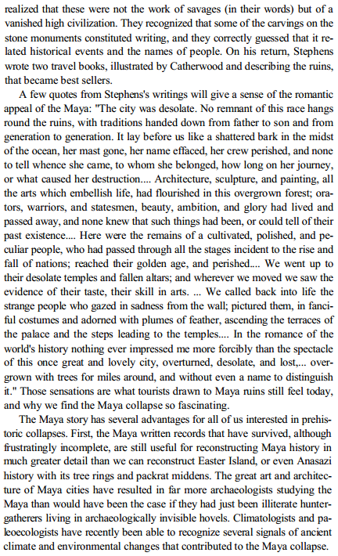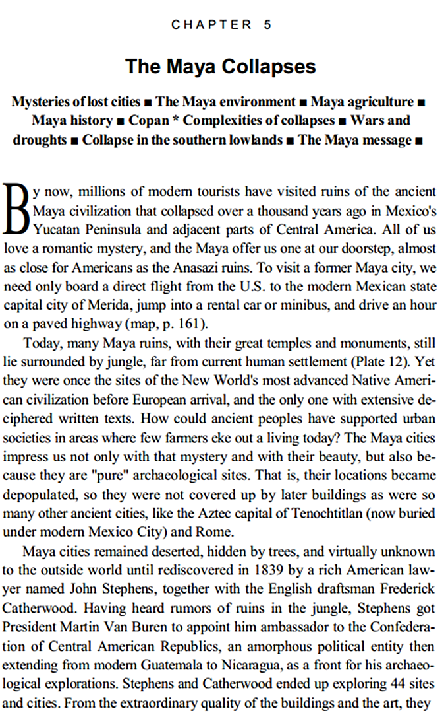

Why is the collapse of the Maya civilization so interesting to Jared Diamond?

**Directions: Carefully and critically read the following excerpts from *Collapse* by Jared Diamond, and then answer the two prompts in the margin.**

**[…]**

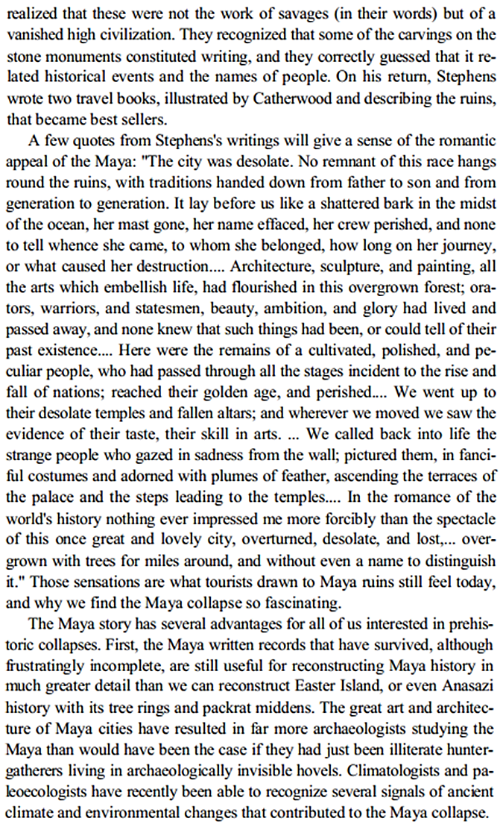

**[…]**

Pick the most interesting factor that lead to the collapse of the Maya. Research. Analyze the factor further. List 3 new pieces of information from one source (informally cite the source).



