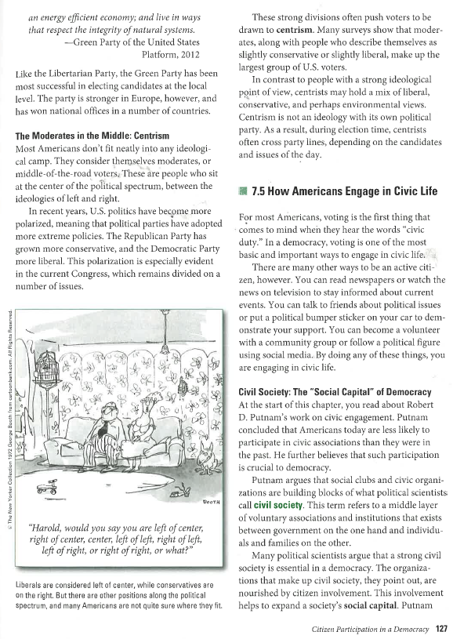
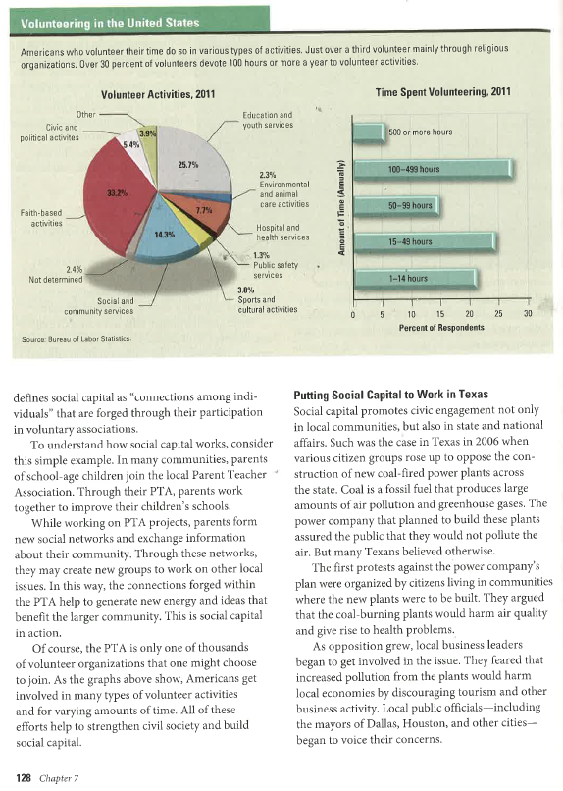
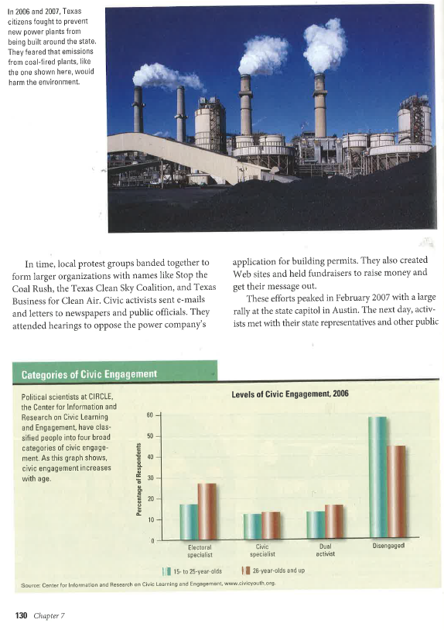
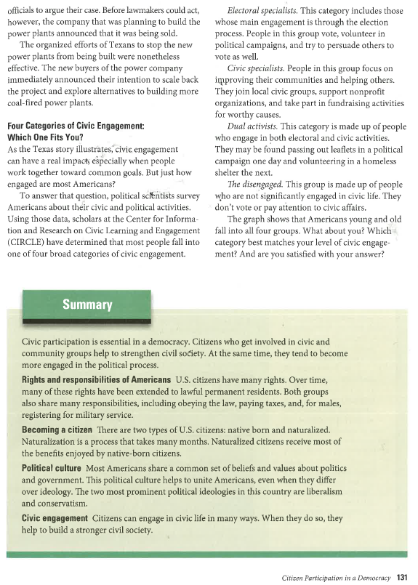
Directions: Answer each of the question in complete sentences and complete thoughts.
- What is a civil society?
- Explain social capital.
- Explain how a civil society and social capital work together.
- Define each of the four categories of civic engagement.
- Argue which of the four categories of civic engagement is the most important.

