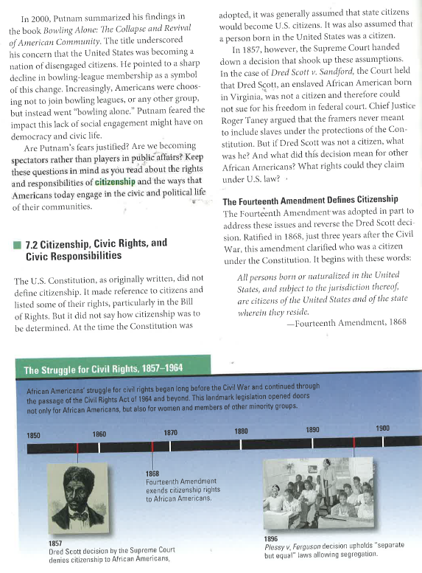
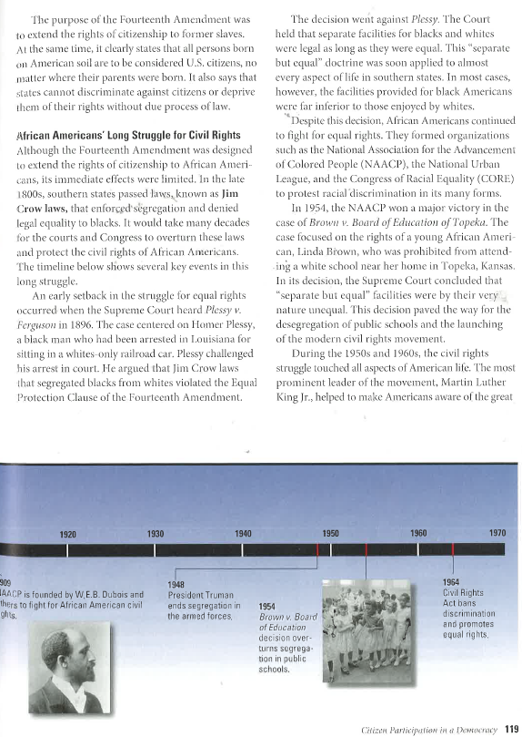
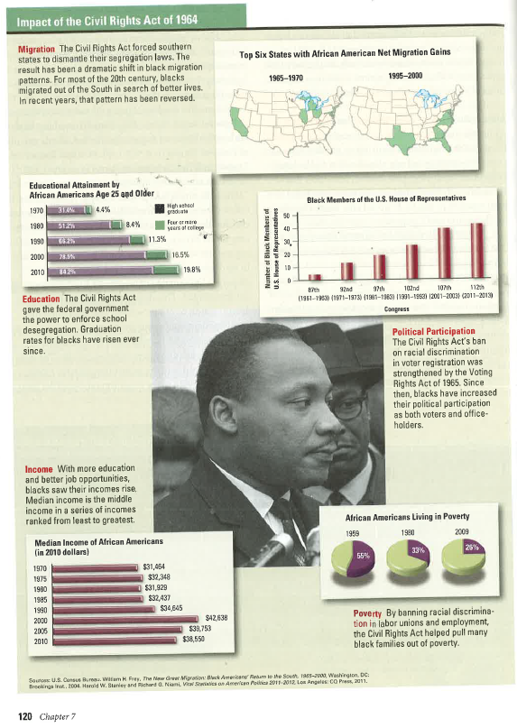
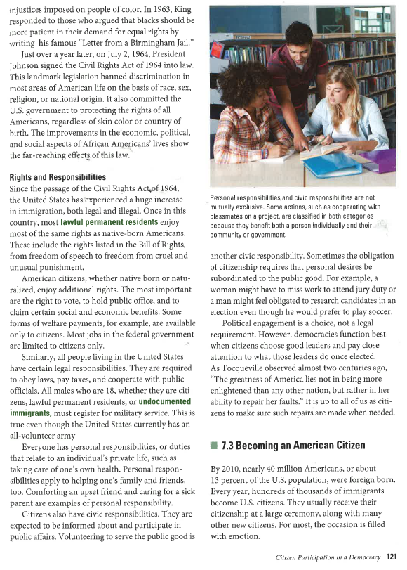
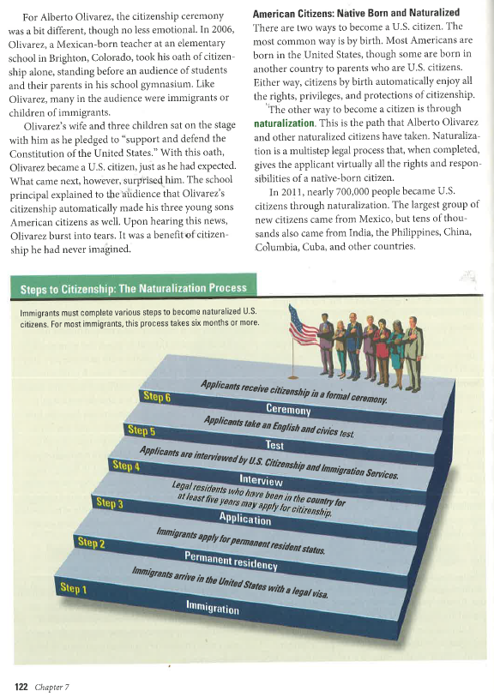
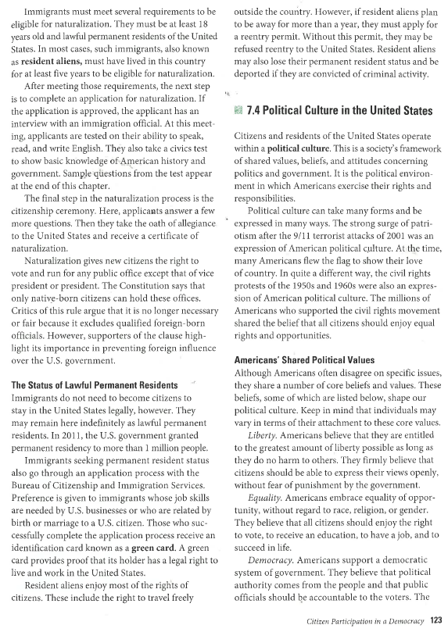
Name:_________________________________________________________

Directions: Answer the following questions in complete thoughts and sentences.

- Did the US Constitution originally address citizenship, what was assumed by the founders who wrote the Constitution?
- Which amendment deals with citizenship? Paraphrase the amendment in your own words.
- What were Jim Crowe Laws?
- What kind of Civil Rights challenges were met by African Americans? Explain with evidence (practice your direct quotes here).
- What is the Civil Rights Act of 1964? Paraphrase.
- What is the difference between Native Born and Naturalized citizens?
- Explain the process an immigrant must go through to become a citizen of the United States.
- Write a thesis statement arguing the impact of the Civil Rights movement. Base your thesis on the information you read in this reading.

