Arik Cohen | Grandchild of four Holocaust survivors
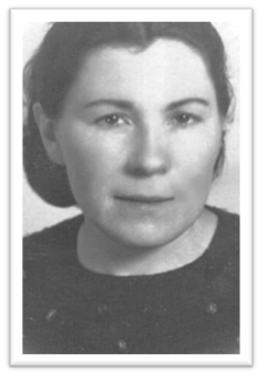
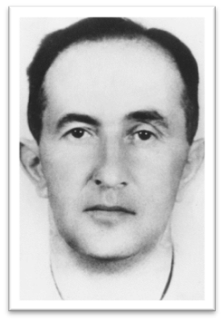

Continuing Generations speaker Arik Cohen tells the unique story of how all four of his grandparents survived the horrors of the Holocaust.

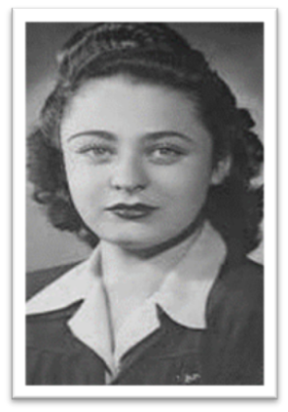
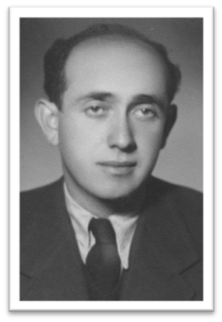
Arik’s maternal grandparents, Arye Schneider and Masha Klein, were both from Lithuania. The Soviet Union invaded Lithuania in June 1940, and when Germany invaded the Soviet Union a year later, the Germans began to take over Lithuania too, including Arye’s town Shukyan.

In the summer of 1941, nearly the entire Jewish population of Shukyan was systematically murdered in various ways. Arye managed to stay hidden, and in November made his way to the Shavli ghetto (20 miles away).

While in Shavli, Arye met his future wife, Masha. Masha was a teacher in the town, having grown up in Neveran, Lithuania and studying at the famous yeshiva in nearby Telshe. Life in the ghetto was difficult in many ways. Space was extremely limited and food was scarce. Going to school eventually became illegal, but Masha and other teachers continued to hold classes secretly. November 5, 1943, was a turning point in Shavli when the Nazis savagely took almost 800 people away.

This cruel act spurred Masha and Arye to escape the ghetto. For the next eight months, they hid in the woods, staying wherever they could. In July 1944, the Russian Army managed to reoccupy and liberate Lithuania from the Nazis. Once the war was completely over, the couple embarked on a difficult journey through Poland, Germany, Austria and over the Alps to Italy, where they stayed until they could immigrate to Israel.

Arik’s paternal grandparents were from Romania. His grandfather Emil Kohn grew up in Suplac, while his grandmother Eva Hirsch was from Gherla, about 50 miles from Suplac. In the chaos of border changes in 1940, this area was ceded to Hungary.

In 1944, the Holocaust began to greatly affect Jews in Hungary. Emil and Eva were forced to live in the Oradea ghetto along with 35,000 other Jews. Although Oradea’s population was 30% Jewish, the ghetto comprised only 6% of the city’s area. In just a few short months in the summer of 1944, over 27,000 Jews in the Oradea ghetto were sent to Auschwitz. Emil and Eva were two of them.

At Auschwitz, Eva planned to stick with her mother, but somehow lost track of her. This ended up ensuring Eva’s survival, for she was pushed into the line for work. Eva never saw her mother again. Eva was sent to Stutthof labor camp, where she worked until forced on a death march in February 1945. On March 11, 1945, after walking for six weeks, Eva was too tired to continue. She slipped away into a barn full of hay and hid. Later that day she was liberated by the Russian Army.

Emil’s story is less certain than Eva’s. Emil was sent to Auschwitz and eventually liberated from Buchenwald in April 1945. Based on documents from Buchenwald, it is possible that Emil and famous Holocaust survivor and writer Elie Wiesel arrived there in the same transport from Auschwitz.

After the war, Emil bicycled all the way back to Oradea from Buchenwald in a month. Eva was already there, and their reunion surely seemed like a miracle. The two started a family in Romania but hoped to leave the Communist nation. In 1958 they were granted permission, and settled in Israel.

Amazingly, both couples ended up living in the small beach town of Nahariya and two of their children (Arik’s parents) met and married. What are the odds that all four of Arik’s grandparents survived the Holocaust? 1 in over 900,000,000. Today Arik lives in Bellevue and shares his grandparents’ amazing stories as a member of the Holocaust Center’s Speakers Bureau.

