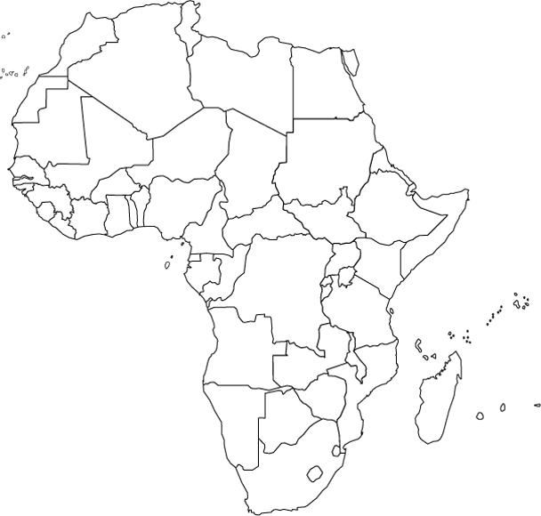

Political Map of Africa
Please label all the countries & capitals of Africa.
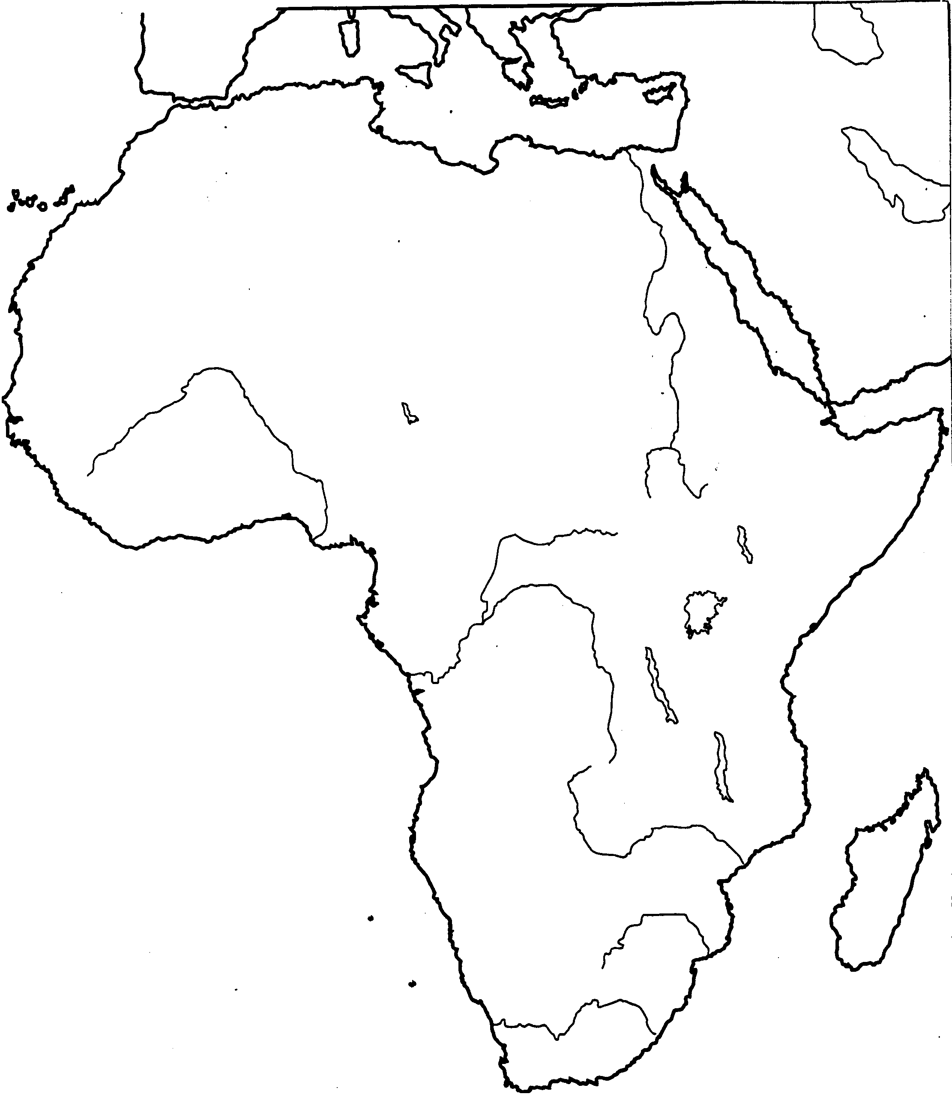

Physical Map of Africa
Please label all the major lakes and rivers.
Please color and label major geographical features:
- Deserts, Large Forests, Sahel, Congo Basin, Mountains, Mountain Ranges, Capes, Gulfs, Oceans, Seas, the Equator, the Tropic of Cancer, the Tropic of Capricorn.

