2cnd Period Actively Learn Code
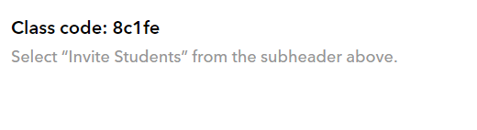
5/6 Actively Learn Code
