Danielson Framework
Name:
Date:
Period:

Instructions: Read the following definition for the Danielson Framework. After reading the instructions analyze the graphic below. Answer the accompanying questions, turn in on Wednesday 4/3/19.

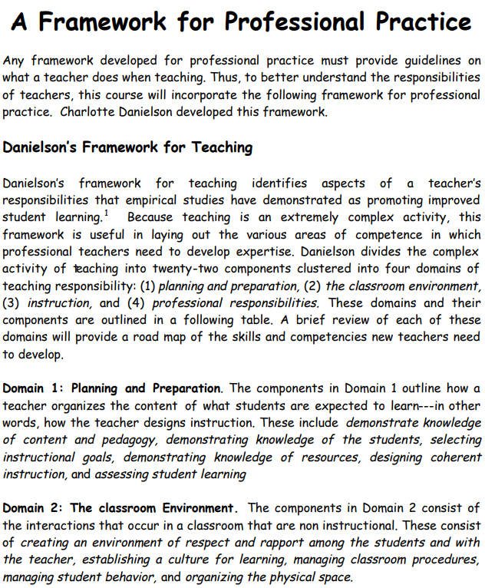

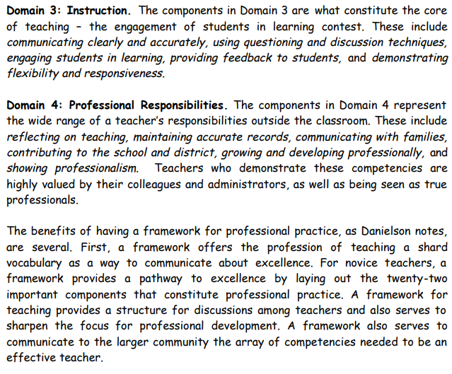

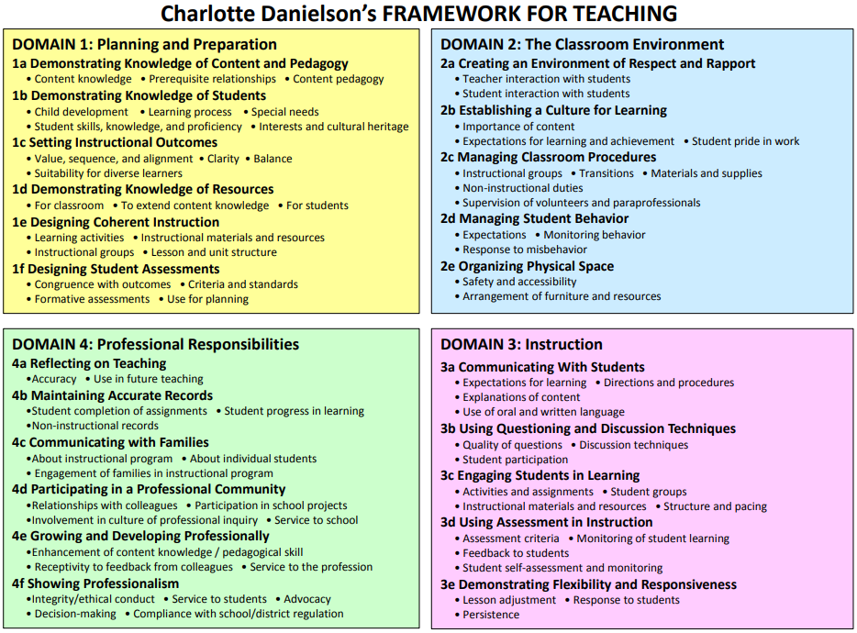

Questions:

- What is the Danielson Framework?
- Why is the Danielson Framework an important part of a teacher’s job/development?
- In your own words define each of the four domains.
  - Domain 1 – Planning and Preparation:
  - Domain 2 – The Classroom Environment:
  - Domain 3 – Professional Responsibilities:
  - Domain 4 – Instruction:
- Of the four domains which do you believe to be the most critical?

