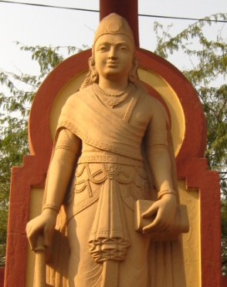
India’s First Empires Reading Guide
Name (A/B):
Due: 2/3/16:
Answer the following questions on a separate sheet of paper:
- How did Chandragupta Maurya unify his empire? How did he pay for this?
- What did Kautilya’s book tell Chandragupta to do?
- Why was Chandragupta paranoid? How did he protect himself?
- What did Asoka do to promote Buddhism in his empire?
- How do you think the period of turmoil impacted religions in India?
- What did daily life look like in the Gupta Empire?
- What caused the fall of the Gupta Empire?
- Using what you learned in class today, draw a Venn diagram to compare Hinduism and Buddhism. Think about: goals, afterlife, terminology, origins, etc.

