Name:

Date:

Period:

Directions: After reading the assignment (last week). Answer the following questions. Please reference the document again if necessary. Answer with complete thoughts and sentences. This will be your score for assignment 4 in the gradebook.
- Which form of research (qualitative/quantitative) do you feel like is the better option for a classroom?
- From a researching perspective which have you completed more throughout high school?
- Do you think you can research information in both styles?
- Which style do you think is more appropriate for collecting data for the elementary classroom?

Qualitative vs. Quantitative Research
By Saul McLeod, updated 2017

There exists a fundamental distinction between two types of data: qualitative and quantitative. The way we typically define them, we call data 'quantitative' if it is in numerical form and 'qualitative' if it is not.
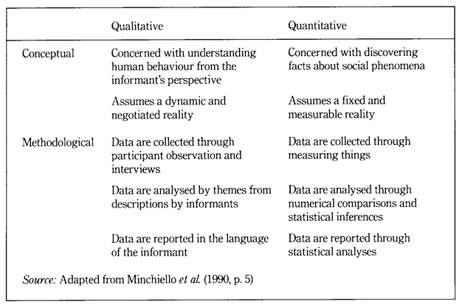

Qualitative Research
Qualitative research is empirical research where the data are not in the form of numbers (Punch, 1998, p. 4).
Qualitative research is multimethod in focus, involving an interpretive, naturalistic approach to its subject matter. This means that qualitative researchers study things in their natural settings, attempting to make sense of, or interpret, phenomena in terms of the meanings people bring to them.
Denzin and Lincoln (1994, p. 2)
An interest in qualitative data came about as the result of the dissatisfaction of some psychologists (e.g., Carl Rogers) with the scientific study of psychologists such as the behaviorists (e.g., Skinner). Since psychologists study people, the traditional approach to science is not seen as an appropriate way of carrying out research, since it fails to capture the totality of human experience and the essence of what it is to be human. Exploring the experience of participants is known as a phenomenological approach (re: Humanism).
The aim of qualitative research is to understand the social reality of individuals, groups and cultures as nearly as possible as its participants feel it or live it. Thus, people and groups, are studied in their natural setting.
Research following a qualitative approach is exploratory and seeks to explain ‘how’ and ‘why’ a particular phenomenon, or behavior, operates as it does in a particular context.

Methods (used to obtain qualitative data)
Qualitative researchers use a variety of methods to develop deep understandings of how people perceive their social realities and in consequence, how they act within the social world.
For example, diary accounts, open-ended questionnaires, documents, participant observation, and ethnography.
The researcher has several methods for collecting empirical materials, ranging from the interview to direct observation, to the analysis of artifacts, documents, and cultural records, to the use of visual materials or personal experience.
Denzin and Lincoln (1994, p. 14)
A good example of a qualitative research method would be unstructured interviewswhich generate qualitative data through the use of open questions. This allows the respondent to talk in some depth, choosing their own words. This helps the researcher develop a real sense of a person’s understanding of a situation.
Notice that qualitative data could be much more than just words or text. Photographs, videos, sound recordings and so on, can be considered qualitative data.

Data Analysis
Qualitative research is endlessly creative and interpretive. The researcher does not just leave the field with mountains of empirical data and then easily write up his or her findings.
Qualitative interpretations are constructed, and various techniques can be used to make sense of the data, such as content analysis, grounded theory (Glaser & Strauss, 1967), thematic analysis (Braun & Clarke, 2006) or discourse analysis.
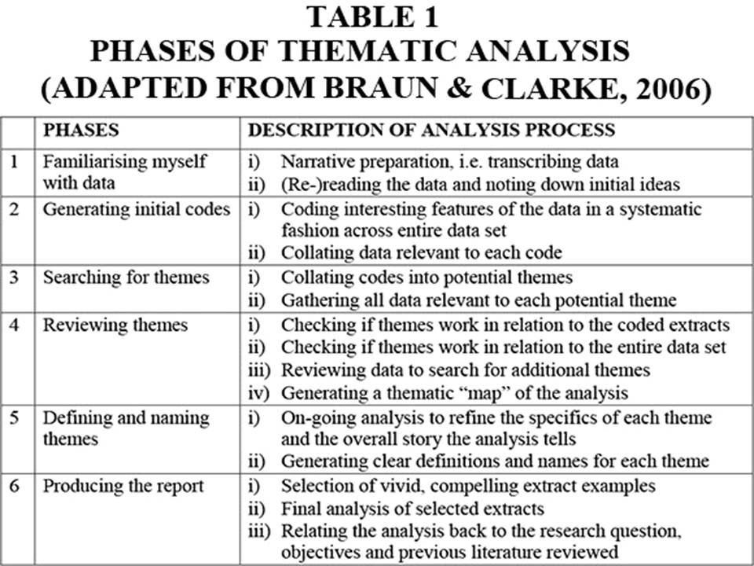
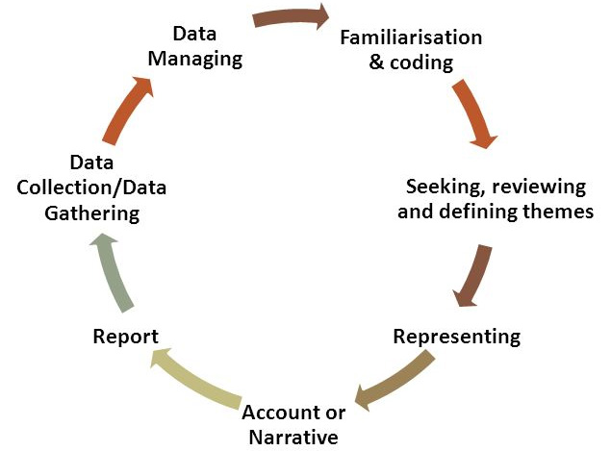

Key Features
Events can be understood adequately only if they are seen in context. Therefore, a qualitative researcher immerses her/himself in the field, in natural surroundings. The contexts of inquiry are not contrived; they are natural. Nothing is predefined or taken for granted.
Qualitative researchers want those who are studied to speak for themselves, to provide their perspectives in words and other actions. Therefore, qualitative research is an interactive process in which the persons studied teach the researcher about their lives.
The qualitative researcher is an integral part of the data, without the active participation of the researcher, no data exists.
The design of the study evolves during the research, and can be adjusted or changed as it progresses.
For the qualitative researcher, there is no single reality, it is subjective and exist only in reference to the observer.
Theory is data driven, and emerges as part of the research process, evolving from the data as they are collected.

Limitations
Because of the time and costs involved, qualitative designs do not generally draw samples from large-scale data sets.
The problem of adequate validity or reliability is a major criticism. Because of the subjective nature of qualitative data and its origin in single contexts, it is difficult to apply conventional standards of reliability and validity. For example, because of the central role played by the researcher in the generation of data, it is not possible to replicate qualitative studies. Also, contexts, situations, events, conditions, and interactions cannot be replicated to any extent nor can generalizations be made to a wider context than the one studied with any confidence
The time required for data collection, analysis and interpretation are lengthy. Analysis of qualitative data is difficult and expert knowledge of an area is necessary to try to interpret qualitative data, and great care must be taken when doing so, for example, if looking for symptoms of mental illness.

Strengths
Because of close researcher involvement, the researcher gains an insider's view of the field. This allows the researcher to find issues that are often missed (such as subtleties and complexities) by the scientific, more positivistic inquiries.
Qualitative descriptions can play the important role of suggesting possible relationships, causes, effects and dynamic processes.
Qualitative analysis allows for ambiguities/contradictions in the data, which are a reflection of social reality (Denscombe, 2010).
Qualitative research uses a descriptive, narrative style; this research might be of particular benefit to the practitioner as she or he could turn to qualitative reports in order to examine forms of knowledge that might otherwise be unavailable, thereby gaining new insight.

Quantitative Research
Quantitative research gathers data in a numerical form which can be put into categories, or in rank order, or measured in units of measurement. This type of data can be used to construct graphs and tables of raw data.
Quantitative researchers aim to establish general laws of behavior and phenonomon across different settings/contexts. Research is used to test a theory and ultimately support or reject it.

Methods (used to obtain quantitative data)
Experiments typically yield quantitative data, as they are concerned with measuring things. However, other research methods, such as controlled observations and questionnaires can produce both quantitative information.
For example, a rating scale or closed questions on a questionnaire would generate quantitative data as these produce either numerical data or data that can be put into categories (e.g., “yes,” “no” answers).
Experimental methods limit the possible ways in which a research participant can react to and express appropriate social behavior. Findings are therefore likely to be context-bound and simply a reflection of the assumptions which the researcher brings to the investigation.

Data Analysis
Statistics help us turn quantitative data into useful information to help with decision making. We can use statistics to summarise our data, describing patterns, relationships, and connections. Statistics can be descriptive or inferential.
Descriptive statistics help us to summarise our data whereas inferential statistics are used to identify statistically significant differences between groups of data (such as intervention and control groups in a randomised control study).

Key Features
Quantitative researchers try to control extraneous variables by conducting their studies in the lab.
The research aims for objectivity (i.e., without bias), and is separated from the data.
The design of the study is determined before it begins.
For the quantitative researcher reality is objective and exist separately to the researcher, and is capable of being seen by anyone.
Research is used to test a theory and ultimately support or reject it.

Limitations
Context: Quantitative experiments do not take place in natural settings. In addition, they do not allow participants to explain their choices or the meaning of the questions may have for those participants (Carr, 1994).
Researcher expertise: Poor knowledge of the application of statistical analysis may negatively affect analysis and subsequent interpretation (Black, 1999).
Variability of data quantity: Large sample sizes are needed for more accurate analysis. Small scale quantitative studies may be less reliable because of the low quantity of data (Denscombe, 2010). This also affects the ability to generalize study findings to wider populations.
Confirmation bias: The researcher might miss observing phenomena because of focus on theory or hypothesis testing rather than on the theory of hypothesis generation.

Strengths
Scientific objectivity: Quantitative data can be interpreted with statistical analysis, and since statistics are based on the principles of mathematics, the quantitative approach is viewed as scientifically objective, and rational (Carr, 1994; Denscombe, 2010).
Useful for testing and validating already constructed theories.
Rapid analysis: Sophisticated software removes much of the need for prolonged data analysis, especially with large volumes of data involved (Antonius, 2003).
Replication: Quantitative data is based on measured values and can be checked by others because numerical data is less open to ambiguities of interpretation. Hypotheses can also be tested because of the used of statistical analysis (Antonius, 2003).

