Name (A/B): _____________________
Due: 3/1/16
Han Emperors in China
Reading Guide

Use the reading to answer the following questions (answers do not need to be in complete sentences!)
As you read, please find at least four inventions from this period of Chinese history:
The Wheelbarrow!

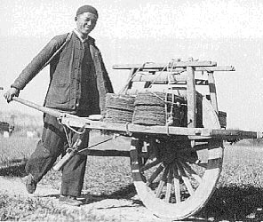
- Why did the Chinese rebel against the Qin?

- How did Liu Bang achieve power?

- What did the Han do that was similar to Shi Huangdi?

- What did the Han do differently than Shi Huangdi?

- How did the Han expand the Chinese empire?
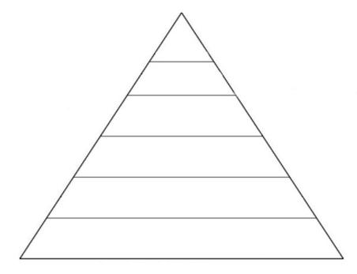
- What was the relationship between the Han and their northern Nomad neighbors?

- Why did Emperor Wudi decide to send an envoy to establish an alliance with the Yuehzi?

- How did the Han defeat the nomads?

- Use the pyramid to transcribe the Han Social order:

- How is the Chinese social order different from the Hindu Caste system? (2 specific differences)

- Why do you think that peasants are above merchants in the Han system?

- What is the role of the emperor?

- How do the gods show displeasure with the emperor?

- Why did Emperor Wudi want people to study Confucius?

- How did Chinese individuals get jobs in the Civil Service?

- How is the examination system like a meritocracy?

- What kept poor people from taking the exams?

- How did the invention of paper affect China?

- How much gold would Romans pay for a pound of Chinese silk?

- What did Confucian scholars consider to be the most honorable profession?

- What is a monopoly?

- What products were monopolized under the Han government?

- Why did the Han government try to keep the process of making silk a state secret?

- How did the Han Dynasty encourage assimilation?

