CHAPTER 3 SECTIONS 1 & 2 – ROOTS OF AMERICAN DEMOCRACY & ENLIGHTENMENT
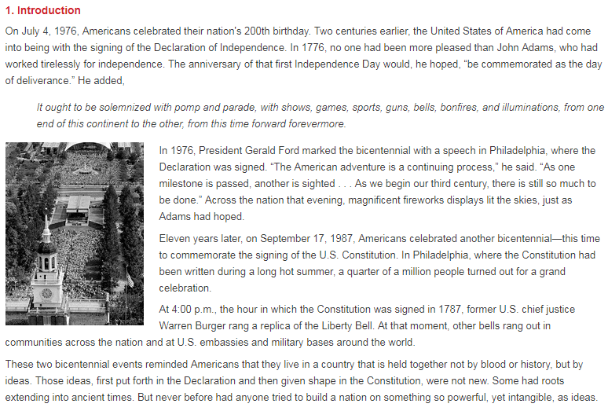

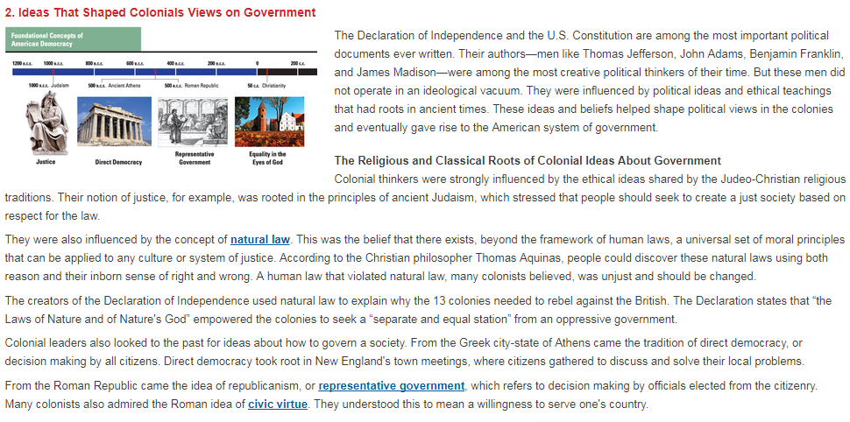

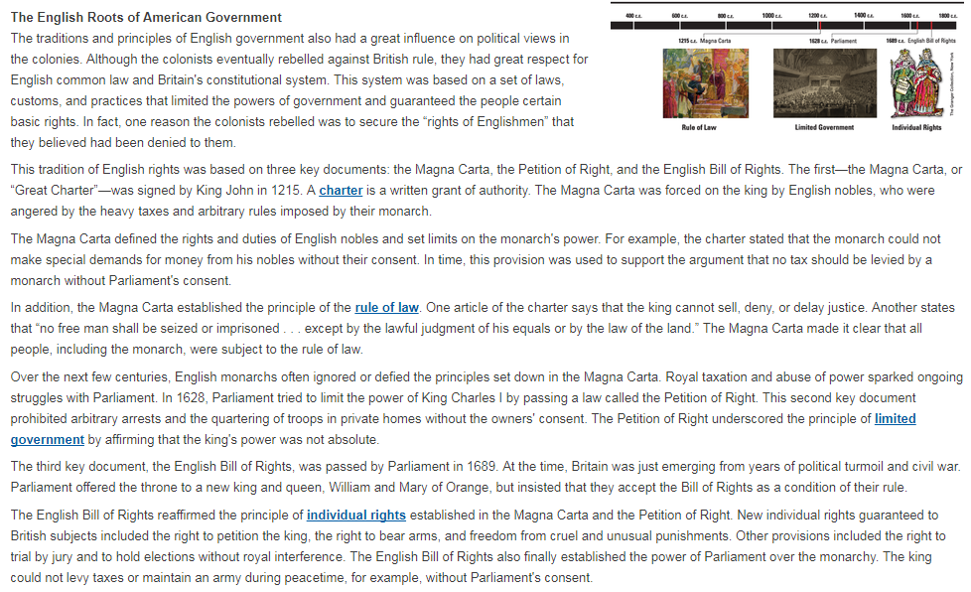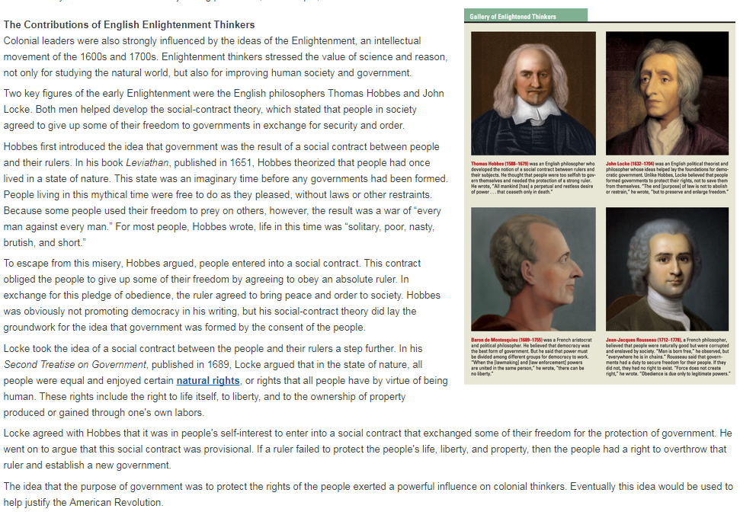
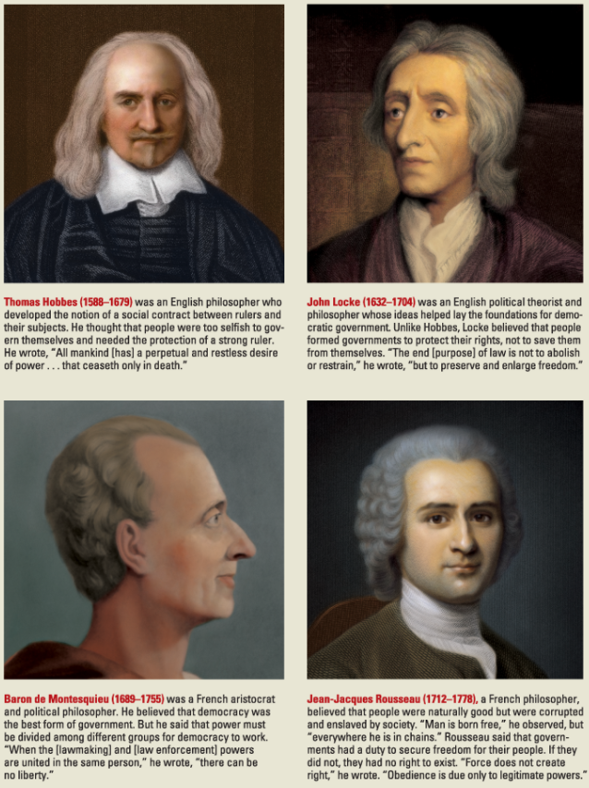

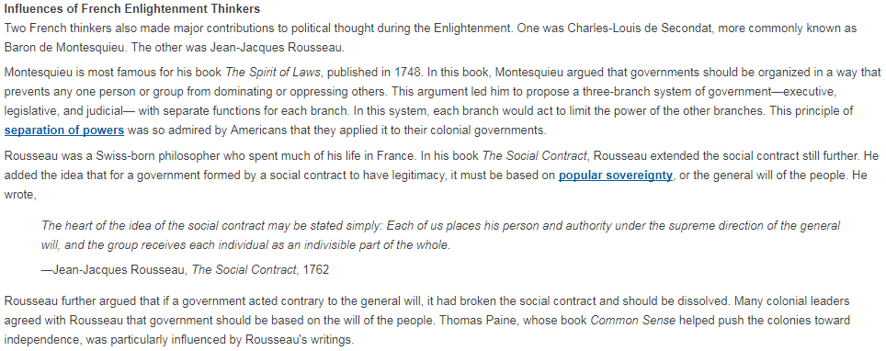
Name:_______________________________________________________________________________________________

Directions: Answer each question carefully. Your answers should be complete, and thorough. You are welcome answer the questions on this sheet, or your own (if you use this sheet, I would space out the questions).

- What is Natural Law, why would our founding fathers think this “law” is important?
- What is a Charter, would the Constitution qualify as a charter?
- What is the Magna Carta?
- Why is the Petition of Right an important document, what does it do?
- Based on this reading who did the founding fathers follow most closely when developing the US Government? (This can be a one word answer)
- What was the Enlightenment?
- Explain what Thomas Hobbes believed. Use evidence (direct quotes) from the article.
- Explain what John Locke believed. Use evidence (direct quotes) from the article.
- How do Hobbes and Locke differ in their opinions?
- What impact did Montesquieu have on US Government?
- Why is the separation of powers “admired by Americans?” Why would the founding fathers use this when creating the US Government?
- What did Rousseau add to the Social Contract Theory?

