Africa Slave Trade

Name:______________________________

Directions: Read the article African and the Transatlantic Slave Trade, then following the directions below.

Prompt: Argue the impact the African Slave trade had on African civilizations.

Thesis: The removal of millions of people from the continent of Africa between 1400 and 1900 as a result of the Transatlantic Slave Trade was the most detrimental event in the history of the continent, ultimately causing conflict amongst Africans.

Based on the previous thesis statement and prompt complete the following tasks.

- Score the thesis statement based on your rubric. Any number 1-4, based on the following criteria.

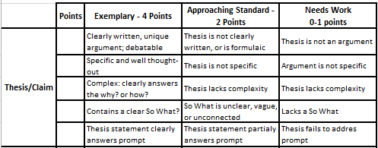

- Defend the thesis statement by writing 2 body thesis statements.

- Find 2 pieces of evidence to defend each body thesis statement, explain why each piece of evidence defends your body thesis statement.

