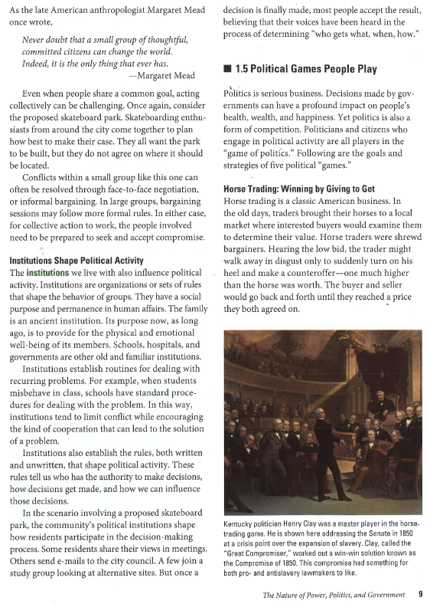

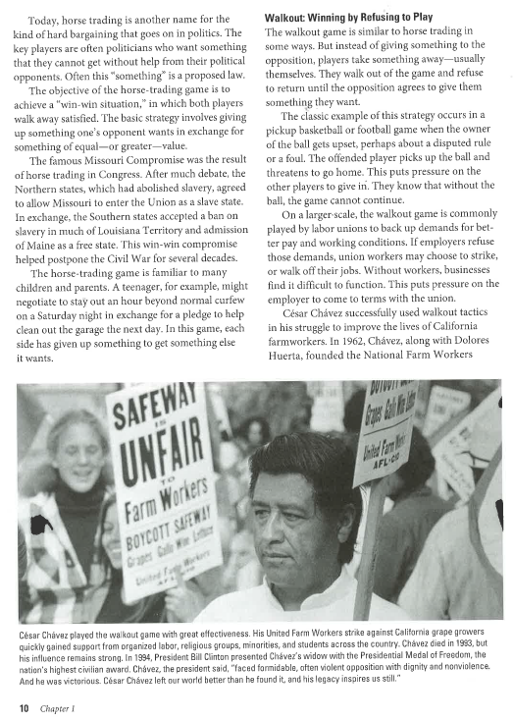

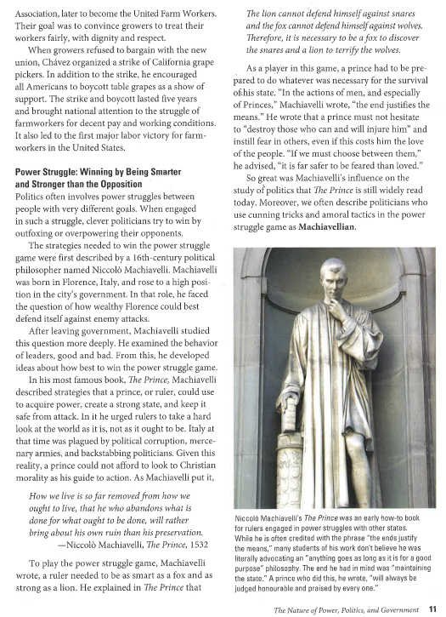

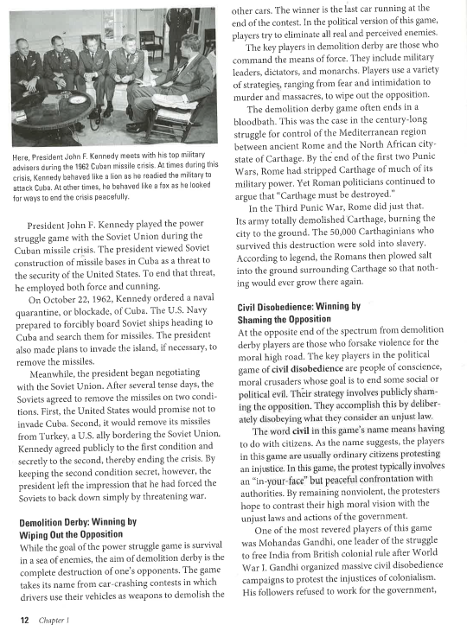

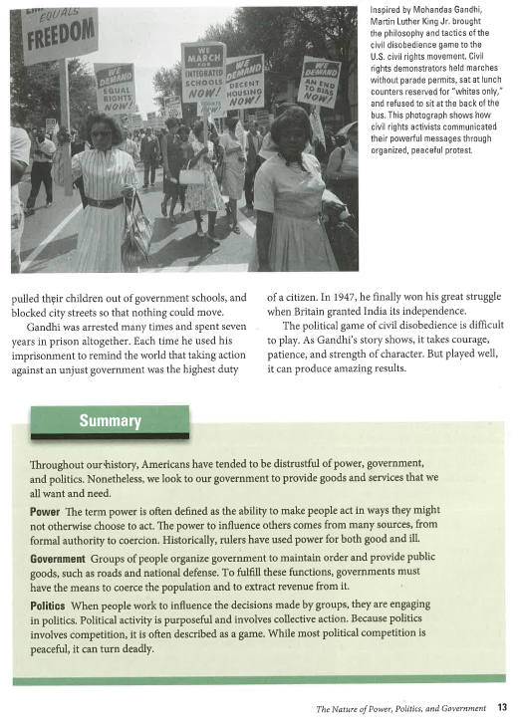

**Answer the following questions based on the previous reading.**

1. **Summarize the ways that people can politically manipulate the government or other people into doing what they want.**
2. **Which of the different manipulation tactics do you think is the most successful? Explain why.**