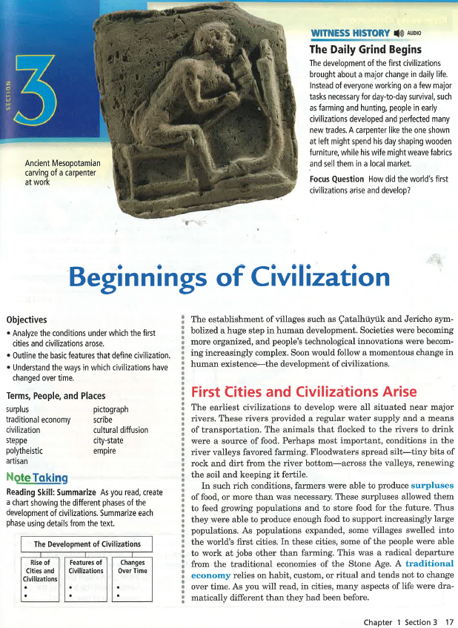
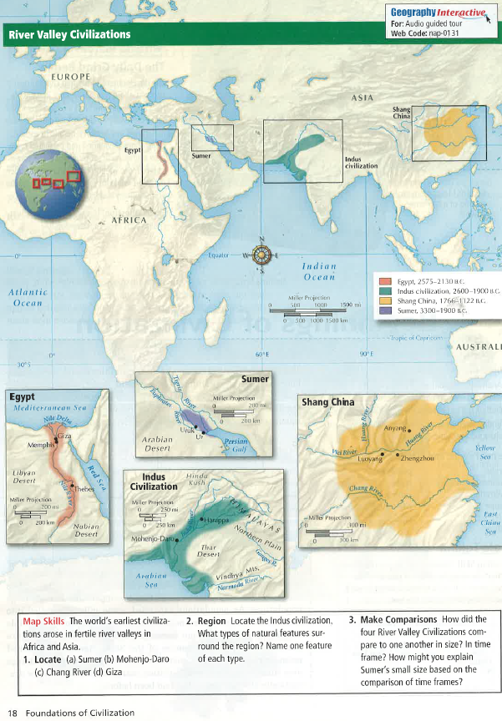
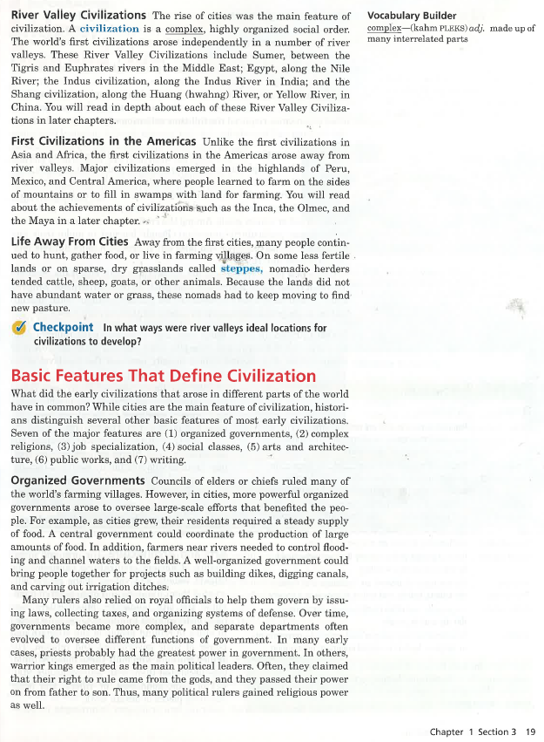
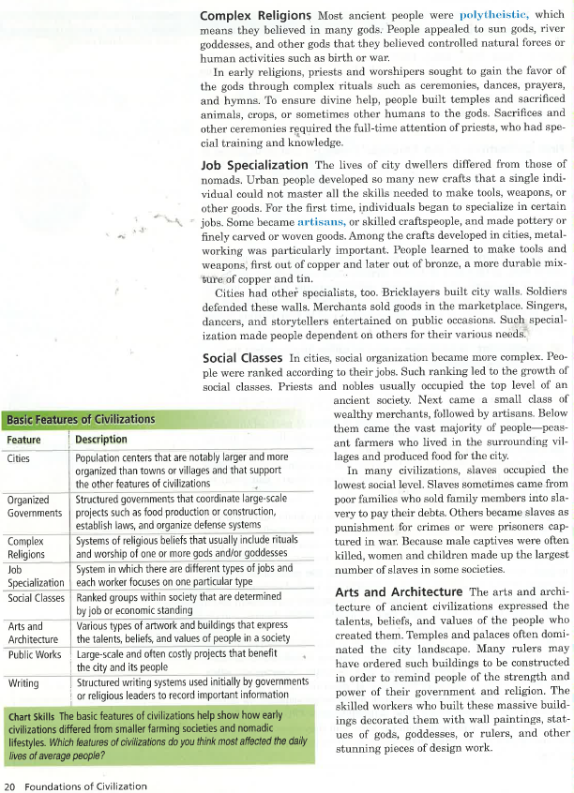
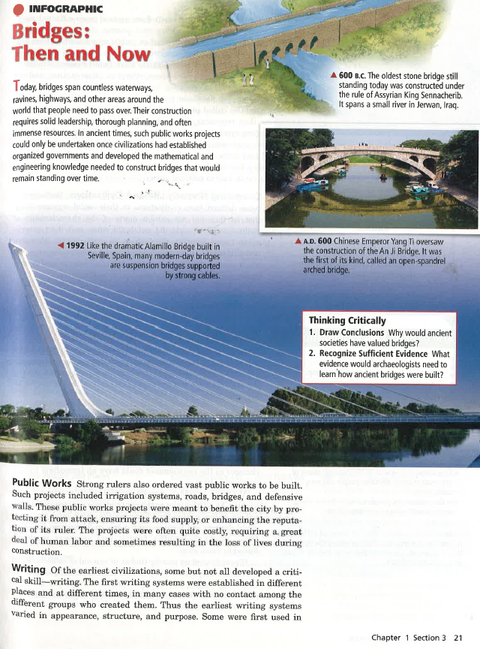
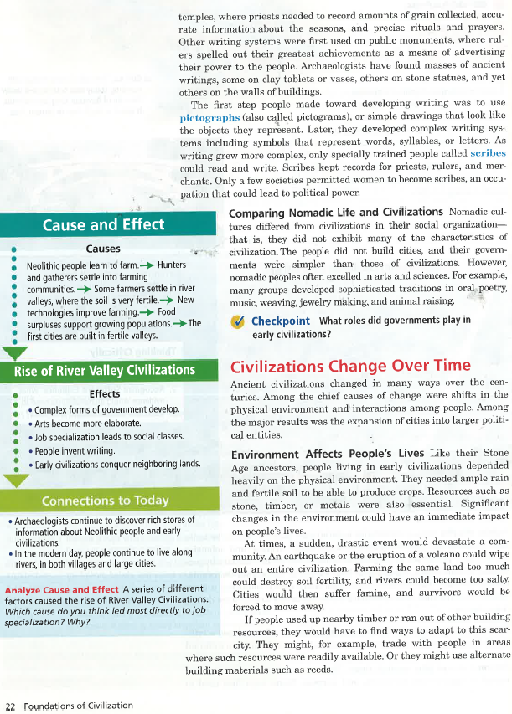
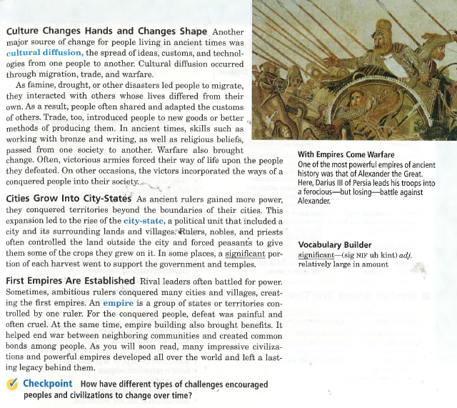
Directions: Read the article and answer the following questions with complete thoughts and sentences.
Pages 17-23
- Explain why the earliest civilizations would have been situated near rivers.
- What is the definition of a civilization?
- Where were the earliest River Valley Civilizations established?
- What is a nomad, why would they need to move around?
- Summarize each of the basic features of a civilization
  - Organized Governments:
  - Complex Religions:
  - Job Specialization:
  - Social Classes:
  - Arts & Architecture:
  - Public Works:
  - Writing:
- What impact did the environment have on ancient civilizations?
- What is cultural diffusion, how did it affect civilizations?
- What is a city-state, is it the same as feudalism?
- What is an empire?

