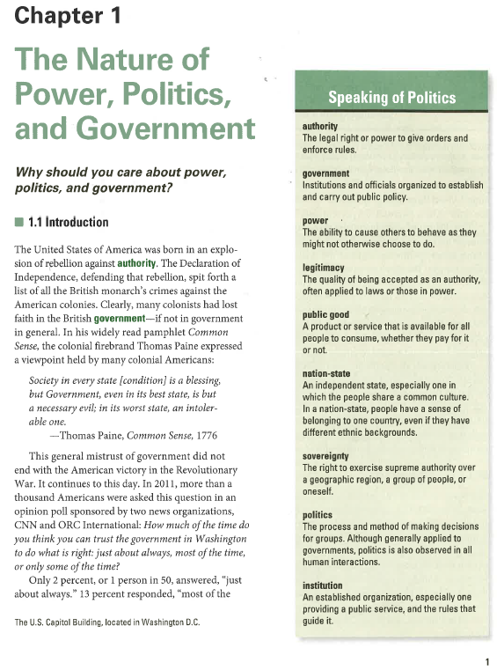

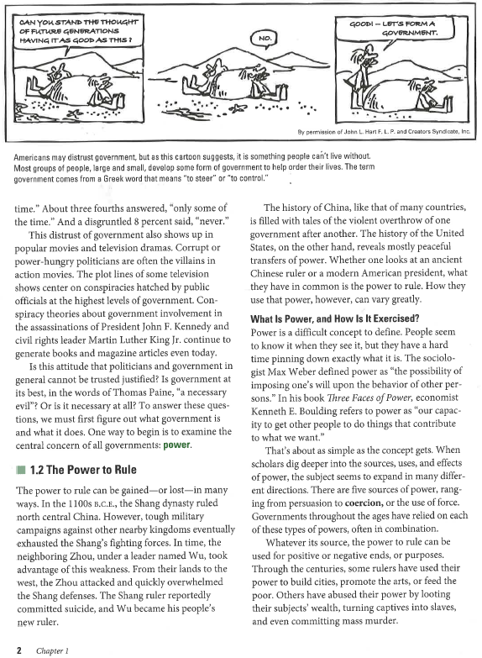

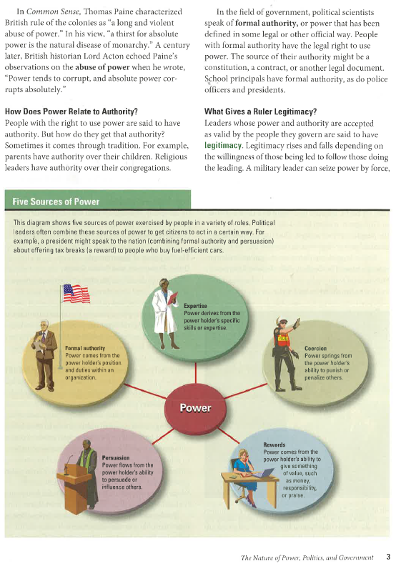

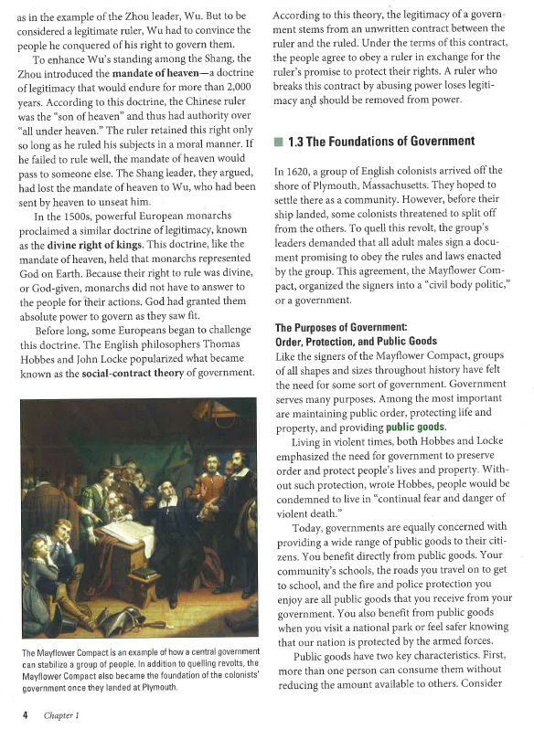

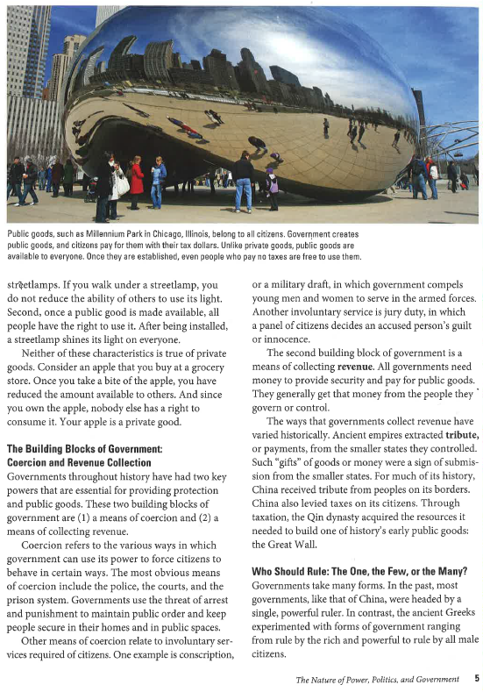

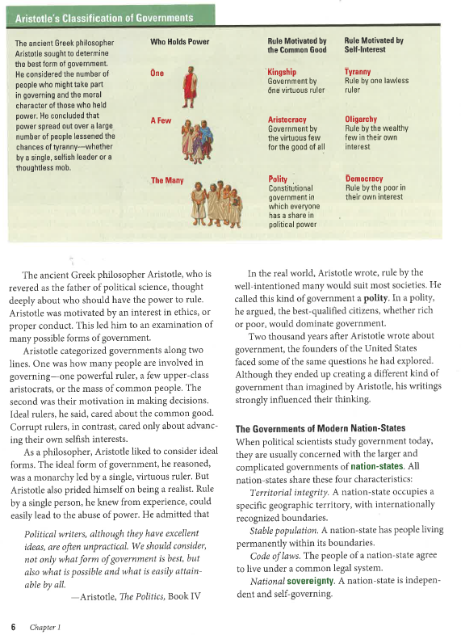

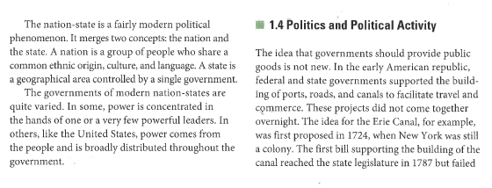

**Answer the following questions based on the previous reading.**

1. **Define *Power* in your own words.**
2. **What are the different forms of governmental power?**
3. **How is/should power be exercised?**
4. **What are the foundations of government?**
5. **What is a Nation State, what are the Four Characteristics of Nation States?**
6. **How did Aristotle classify governments?**