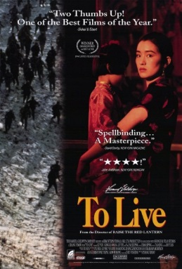
Name: (A/B) _________________
To Live
Viewing Guide

Take notes on the lives of the family in To Live.

Describe their life before the Revolution:

How does the Chinese Civil War affect them?

How does the Communist Revolution affect the family?

How does the Great Leap Forward affect the family?

How does the Cultural Revolution affect the family?

What do you think about the experience of this Chinese family in the 20th century? What does this story tell us about China’s recent history?

